Department of Computer Engineering and Informatics

*Faculty of Science and Technology, Middlesex University Dubai*



**CST1340**

**Information in Organisations**

**Coursework Group Report**

**Student Names: Anastasia Kajalic (M00982467) | Basma Sameer (M01040352) | Raghad Barmem (M01039213) | Shaavetha Mohankumar (M01039389)**

Module Lecturer: Dr. Sumitra S Kotipalli

Submission Date: 11/04/2025

**Table of Contents**

1. **Introduction**
   1. Aim
   2. Assignment Deconstruction & Objectives
   3. Storyboard
2. **HTML - HyperText Markup Language & CSS - Cascading Style Sheets**
   1. CSS - Explanation of Code
3. **XML - Extensible Markup Language**
   1. XML Schema
   2. Explanation of Code
4. **Validation with DTD**
5. **Transformation**
   1. XSLT - Explanation of Code
   2. Data Transformation - XML to XHTML
6. **Validation**
   1. XML Validation
   2. HTML Validation
   3. CSS Validation
7. **Author Contributions**
8. **Reflection**
9. **Takeaways & Conclusion**
10. **References**

**Section 1: Introduction**

The foundational building block of any website would be Hypertext Markup Language (HTML), a standard markup language that makes use of a wide variety of elements, including headings, paragraphs, lists, tables, images and forms to structure content. HTML works in close relation with Cascading Style Sheets (CSS) which defines and applies styles consistently across all pages of a website. This results in shaping user-friendly and attractive web pages. Additionally, eXtensible Markup Language (XML) and eXtensible Stylesheet Language (XSLT) complement each other to transform and present data. The Document Type Definition (DTD) helps validate and constrain XML structures.

Our group project, ‘*Rustic Rhythms*’, is a simulated multi-page music record store website. It implements and transforms knowledge from HTML, CSS, XML, XSLT and DTD, resulting in a website that is interactive in nature. Each page demonstrates specific web development skills:

* HTML includes paragraphs, lists, tables, headings, and more, and CSS applies consistent design to our pages, providing a clean look.
* Two XML stores the music record data, which is validated through our DTD file.
* Both XML data is transformed into readable and stylised tables, formatted using XSLT.

*1.1. Aim*

The aim of this coursework was to design and implement a functional and visually cohesive website using HTML, CSS, XML, XSLT, and DTD. This report highlights the storyboard board and brainstorming process, presenting the in-depth understanding and validation of each web development tool through explanation of code, and individual takeaways each member took towards the completion of the assignment.

*1.2. Assignment Deconstruction & Objectives*

This assignment was broken down into six major objectives, which would allow us to deconstruct the nature of the assignment:

* User-friendly and Interactive Main Page and Web Pages: A HTML file displaying introduction, contact details and opening times of the shop.
* Styling and Formatting of Website via implementation of CSS: Maintains a cohesive style and ensures simplification of future updates.
* Storage of Album Details via XML: Storing large volumes of album information in XML, organised as element trees for retrieval.
* Viewing of Inventory via implementation of XSLT: Simplifies the conversion of XML data alongside XPath.
* Validation of XML file via DTD: Ensures data accuracy and consistency of XML file.
* Designing a Brand Identity: Achieved by creating logo and, choosing a colour palate, imagery and typography.

*1.3. Storyboard*

The storyboard was a quintessential process for the coursework as it helped in understanding each team member's vision in creating the website and dividing responsibilities. This early planning stage helped us visualise what the layout of each page should be, how many pages there should be, deciding what functionalities, elements, and styles were necessary, which ensured each team member had clear objectives to fully complete this coursework. The storyboard process was long and took us a week to complete, but was crucial in shaping our structure for both the main pages and XML pages, navigation flow and user functionality, and allowing us to decide a standardised colour scheme, logo, and typography that formed our brand identity. Furthermore, it allowed us for any feedback and improvements which could be easily altered at this early stage.

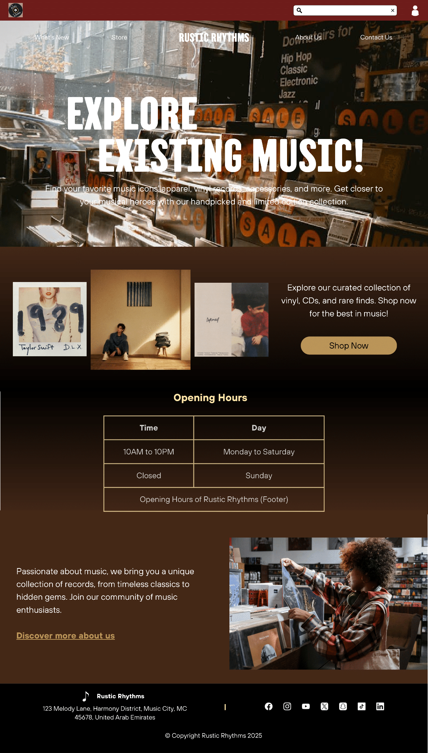

**Fig. Main Page**

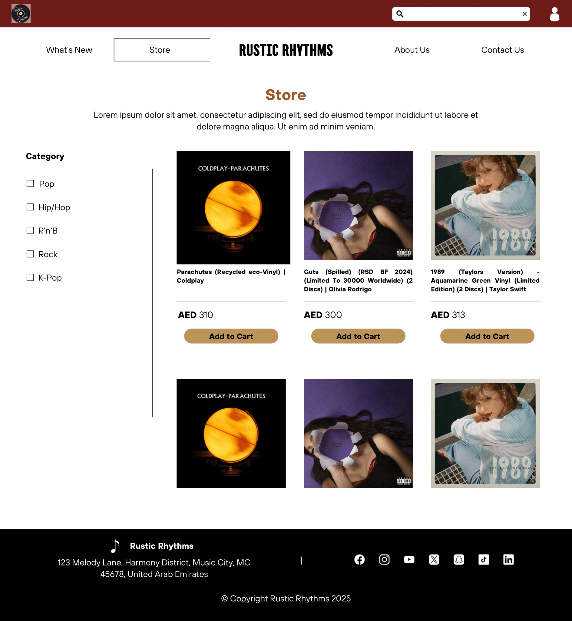 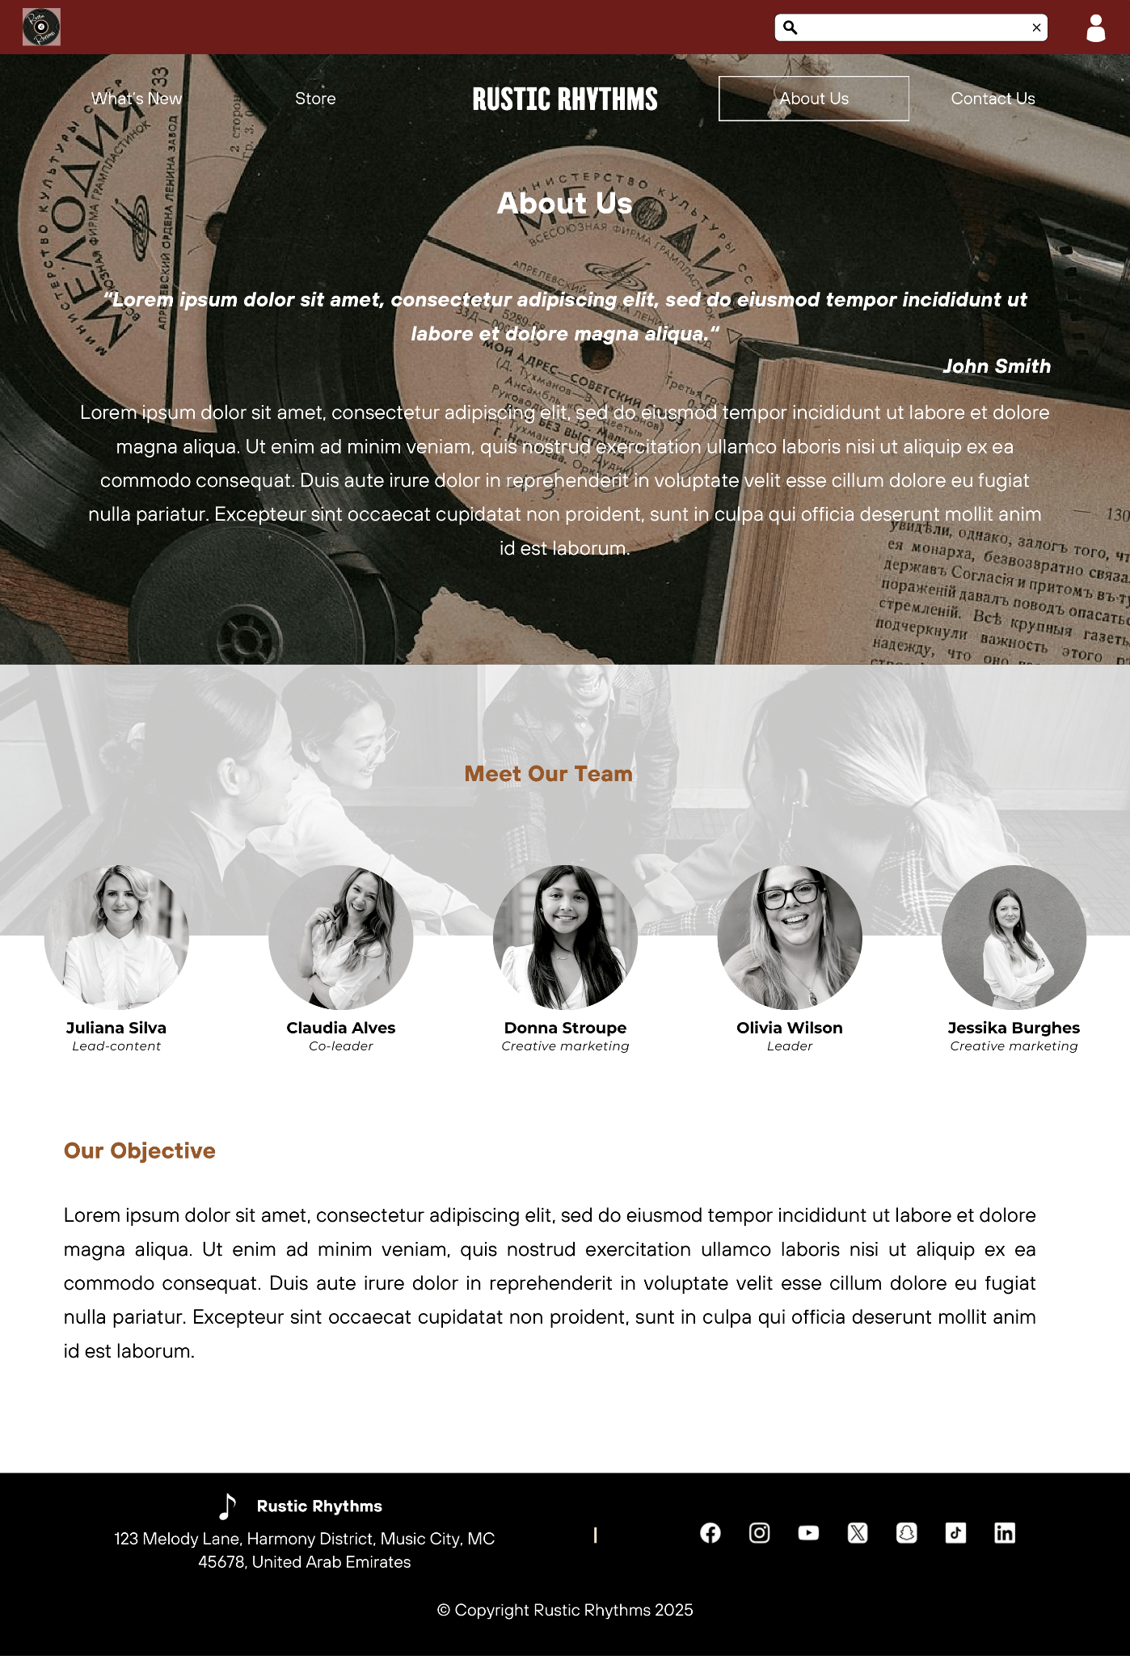

**Fig. Store Front and About Us Page**

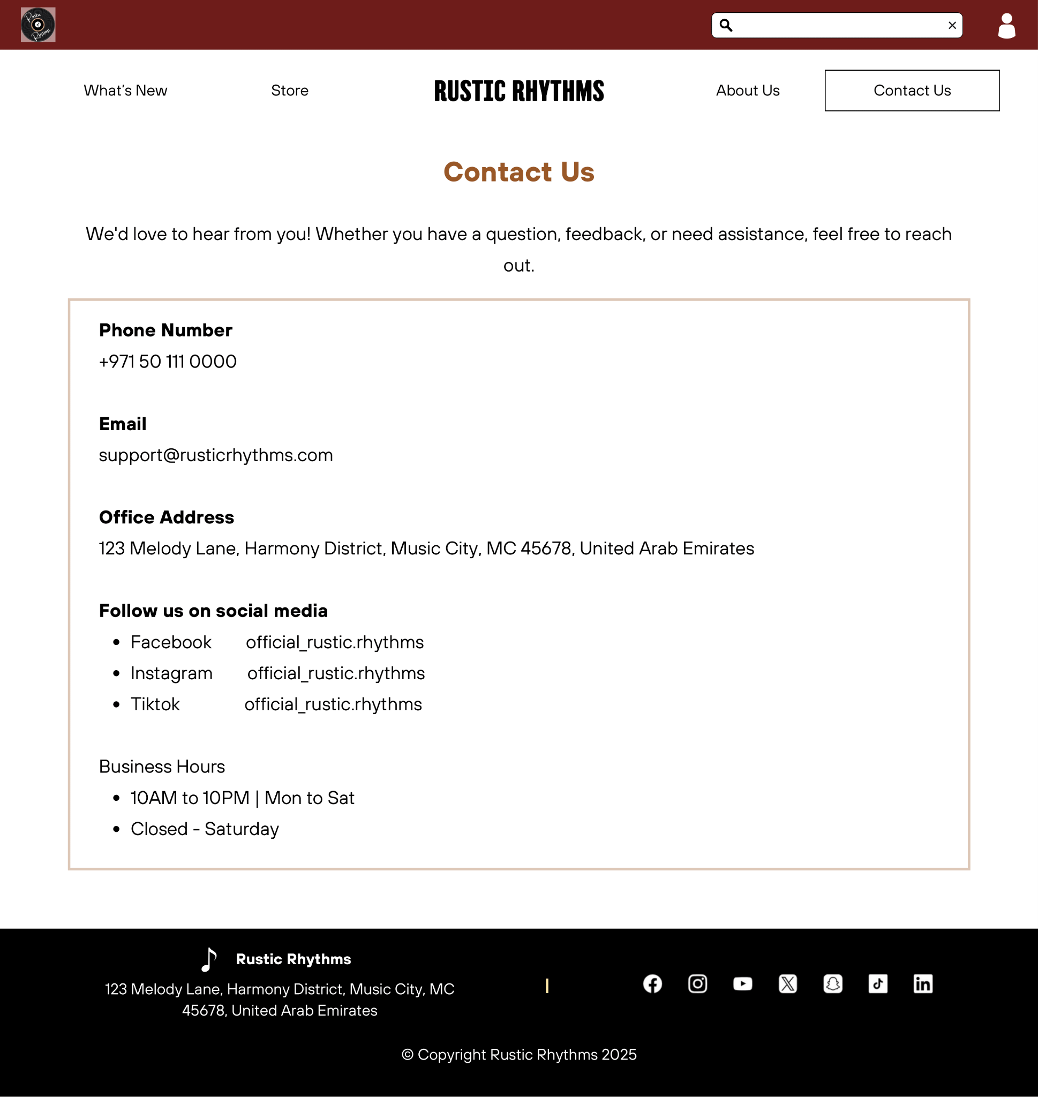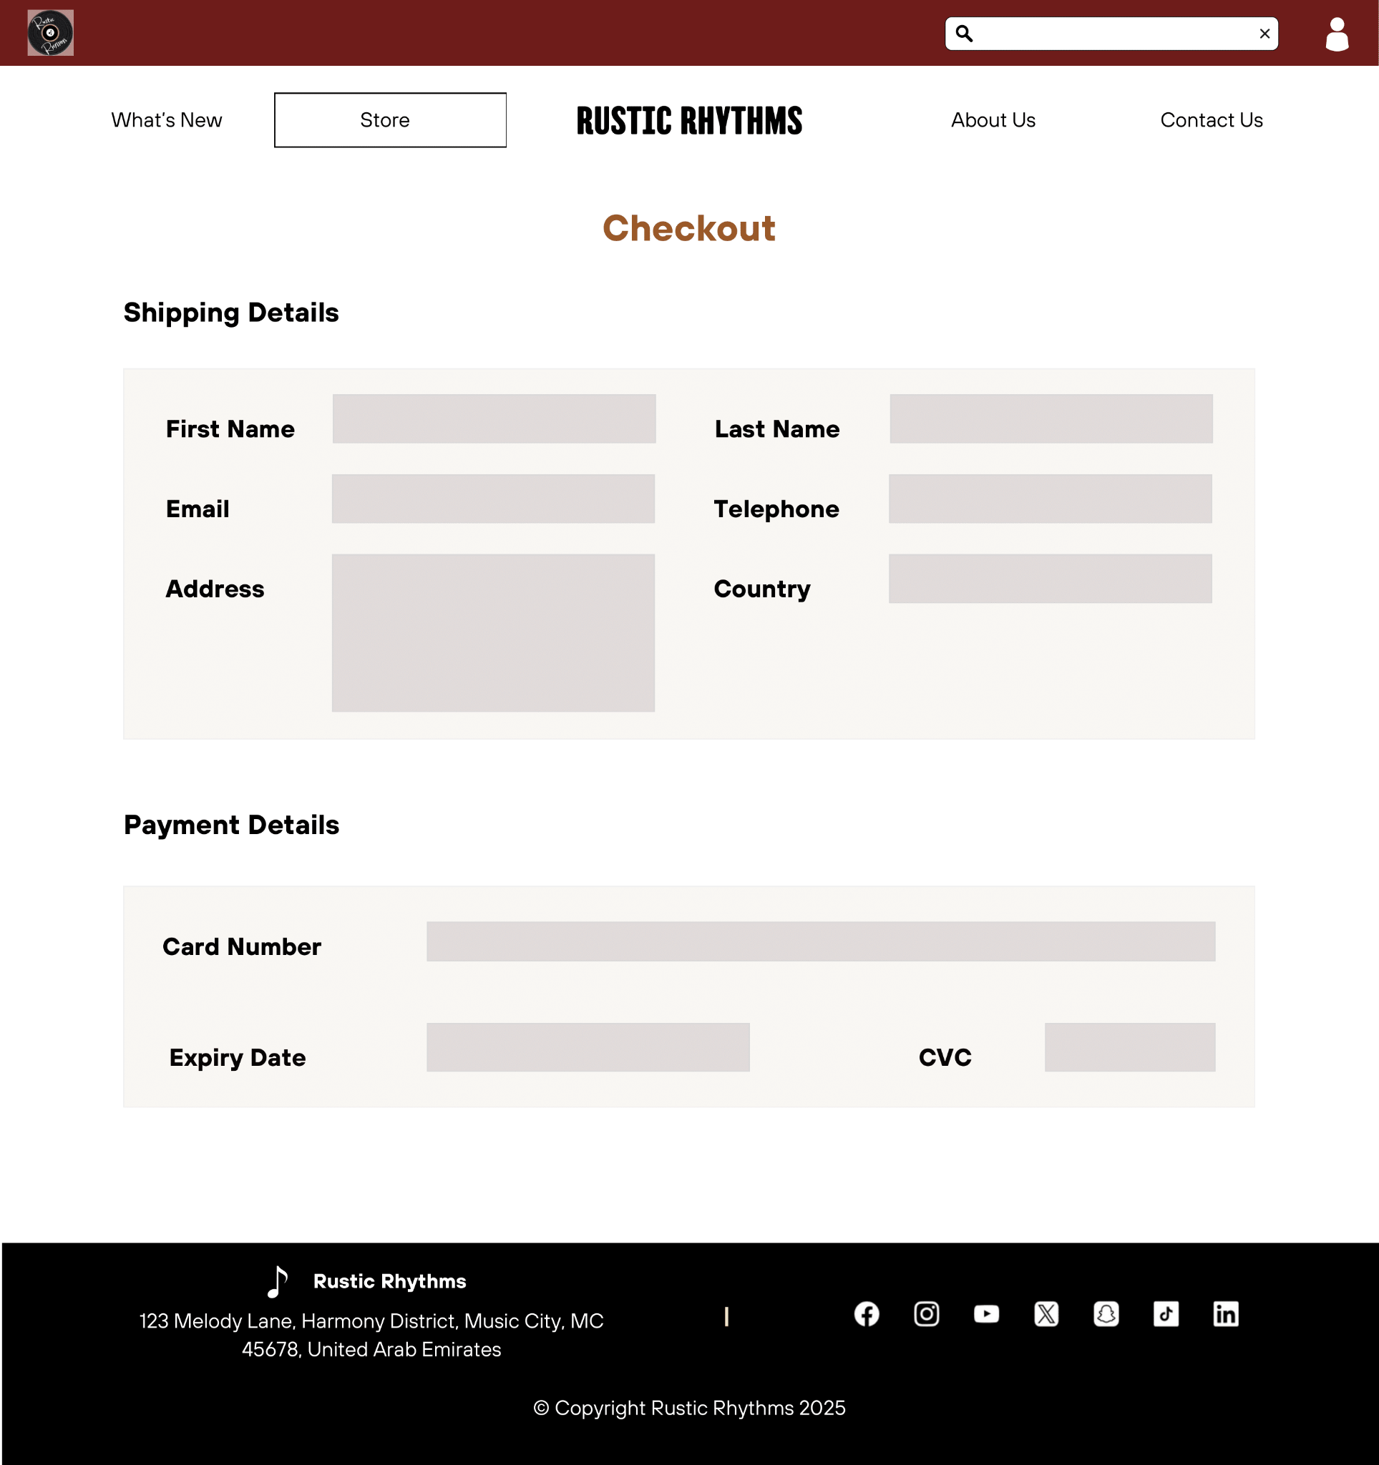

**Fig. Contact Us and Checkout Page**

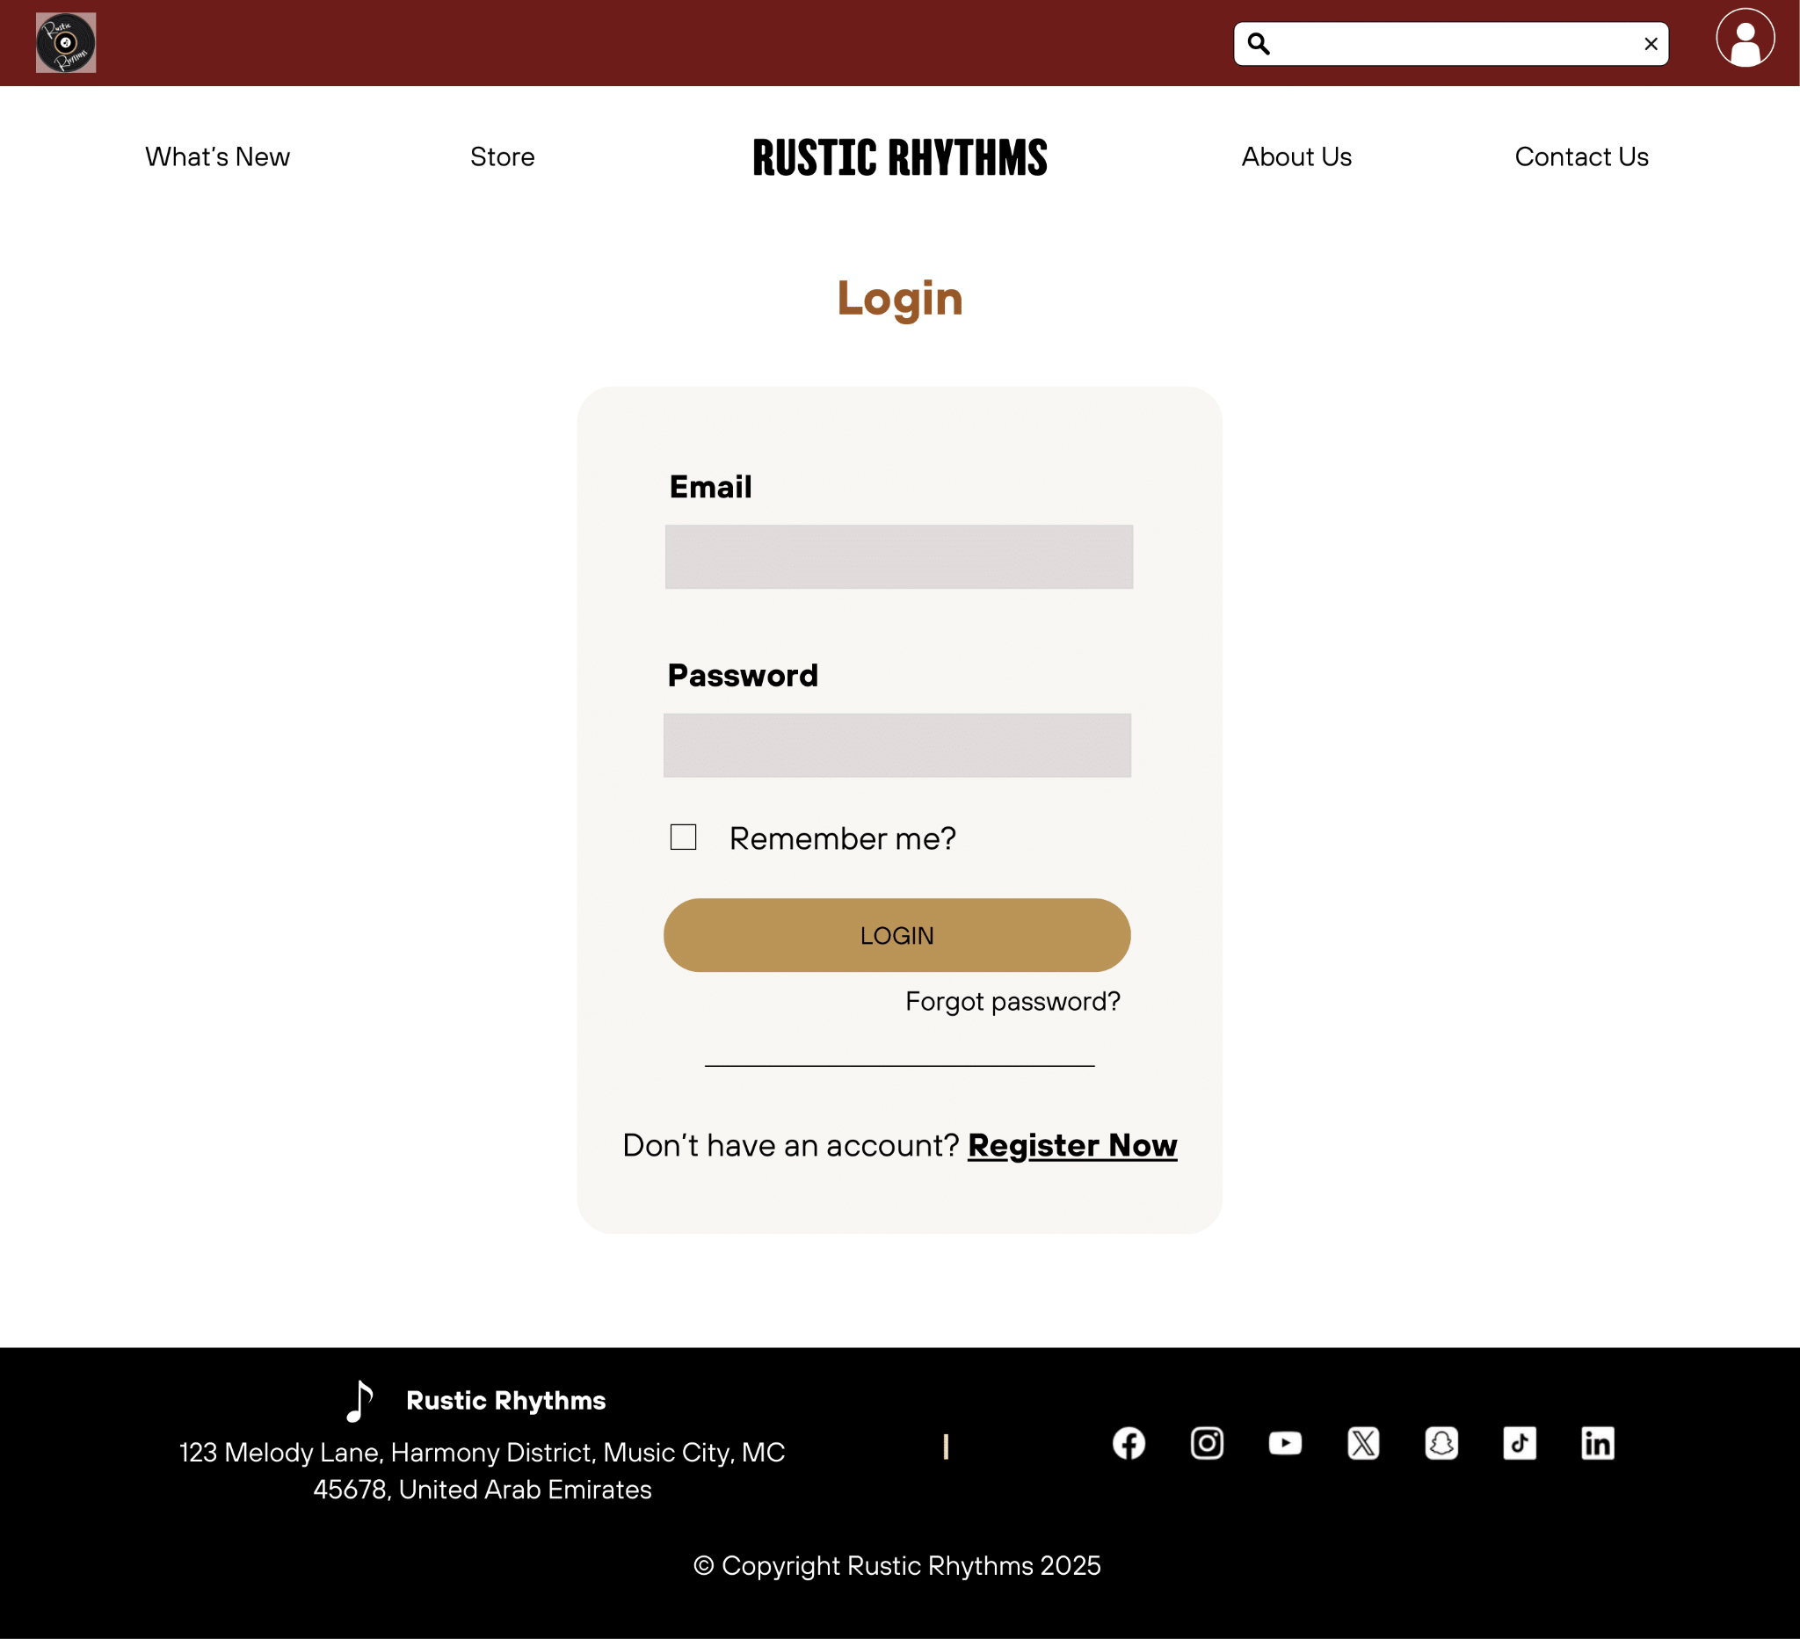

**Fig. Login Page**

**Section 2: HTML - HyperText Markup Language & CSS - Cascading Style Sheets**

**Index.html**

Index.html is the front-page of our website where the user first lands on, including the welcome page, a promotional featured albums section, a table of opening hours, and an About Us preview section. The HTML file uses <section>, <nav>, and <footer> to section the code, referencing styles.css for external styling, ease of control and organisation.

* The welcome section is referred to with .hero, displayed with a background image, headline, and subtitle. It uses flexbox containers and animation using @keyframes fadeInUp for fade-in transitions.
* Below the hero section displays three album covers and a promotional message linking to store.xml. It is styled with .featured, using .album-grid and .shop-promo for aid with scroll-triggered animation control.
* The table uses both internal and external styling with .hours, showing the opening hours of the store. It includes a footer <tfoot> and table header <th>, using <strong> to bold the text. It uses the nth-child attribute to help with equalising the structure of the table.
* About Preview is a short description that links the user to about.html and includes an image. It uses .about-preview and .about-content for styling, with more scroll-linked animation.

The bar at the top (Top Bar), navigational bar (Navbar), side navigation bar (Sidenav), and footer are present in all pages.

* The Top Bar, .top-bar, contains a logo, search bar, and user icons linking to login.html and checkout.html, using .top-bar for layout and positioning.
* Navbar uses .navbar and position: sticky; to ensure that the navigational system stays on the top even when the user scrolls away. It allows for the user to navigate to any of the other three pages linked, About Us, Contact Us, and Store, as well as navigate back to the home page (index.html).
* Sidenav is a vertical navigation bar on the left controlled with .side-nav and IDs present next to div classes of important sections in web pages. It uses # to call back to the ID, allowing the user to be directly brought to the desired section with contextual titles on the side.
* The .footer displays business info and social media icons, divided using display: grid; to separate and equalise the information.

**Front Page Annotation (with Index.html and Styles.css)**

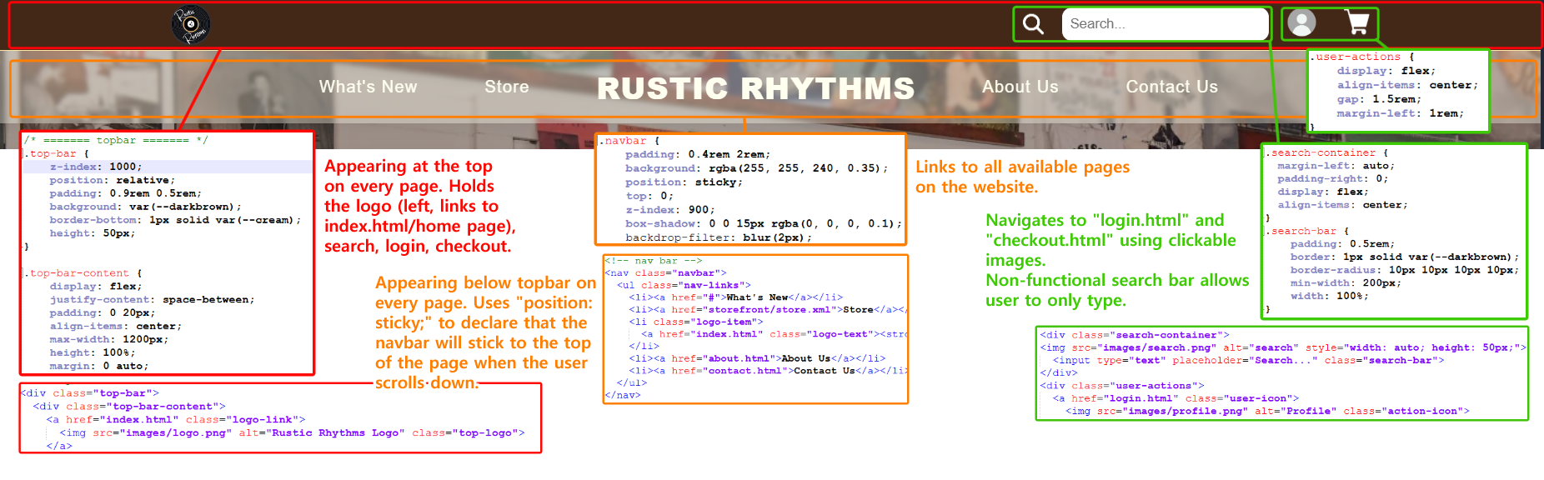

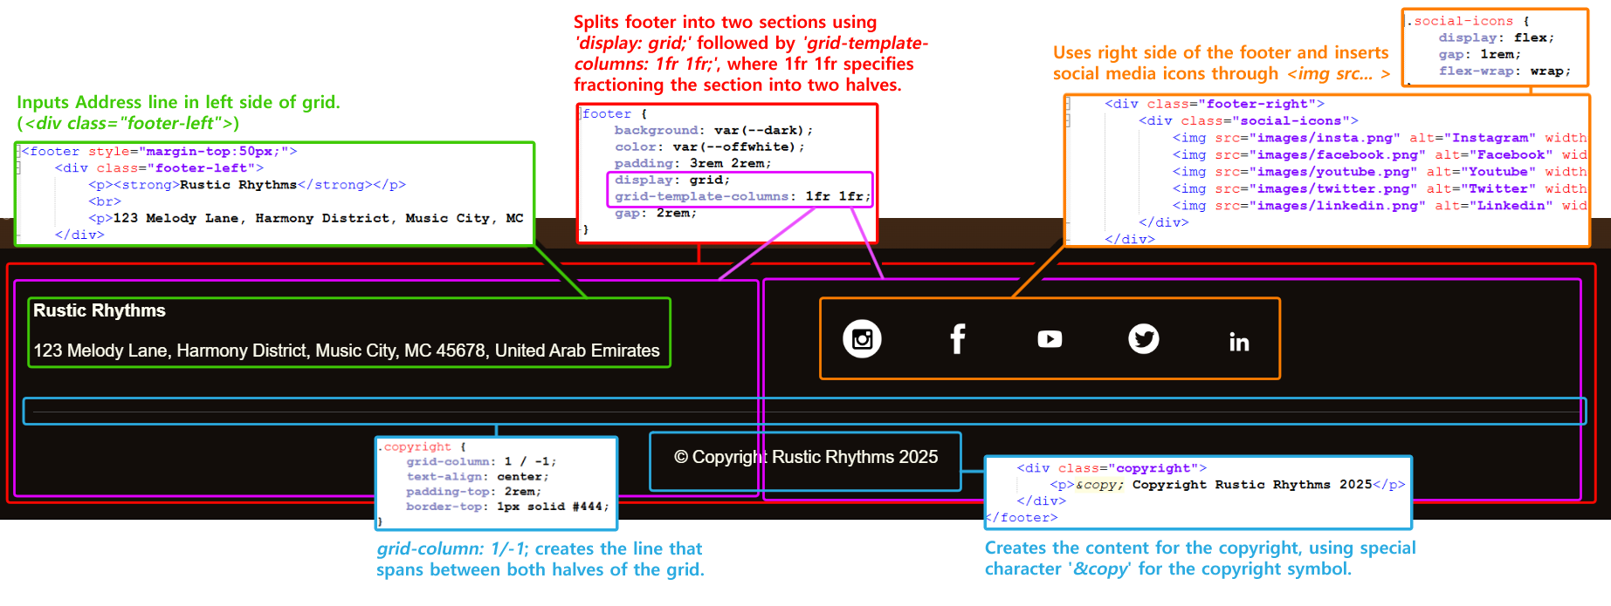

**Fig. Annotated Screenshot of Top Bar, Navbar, and Footer**

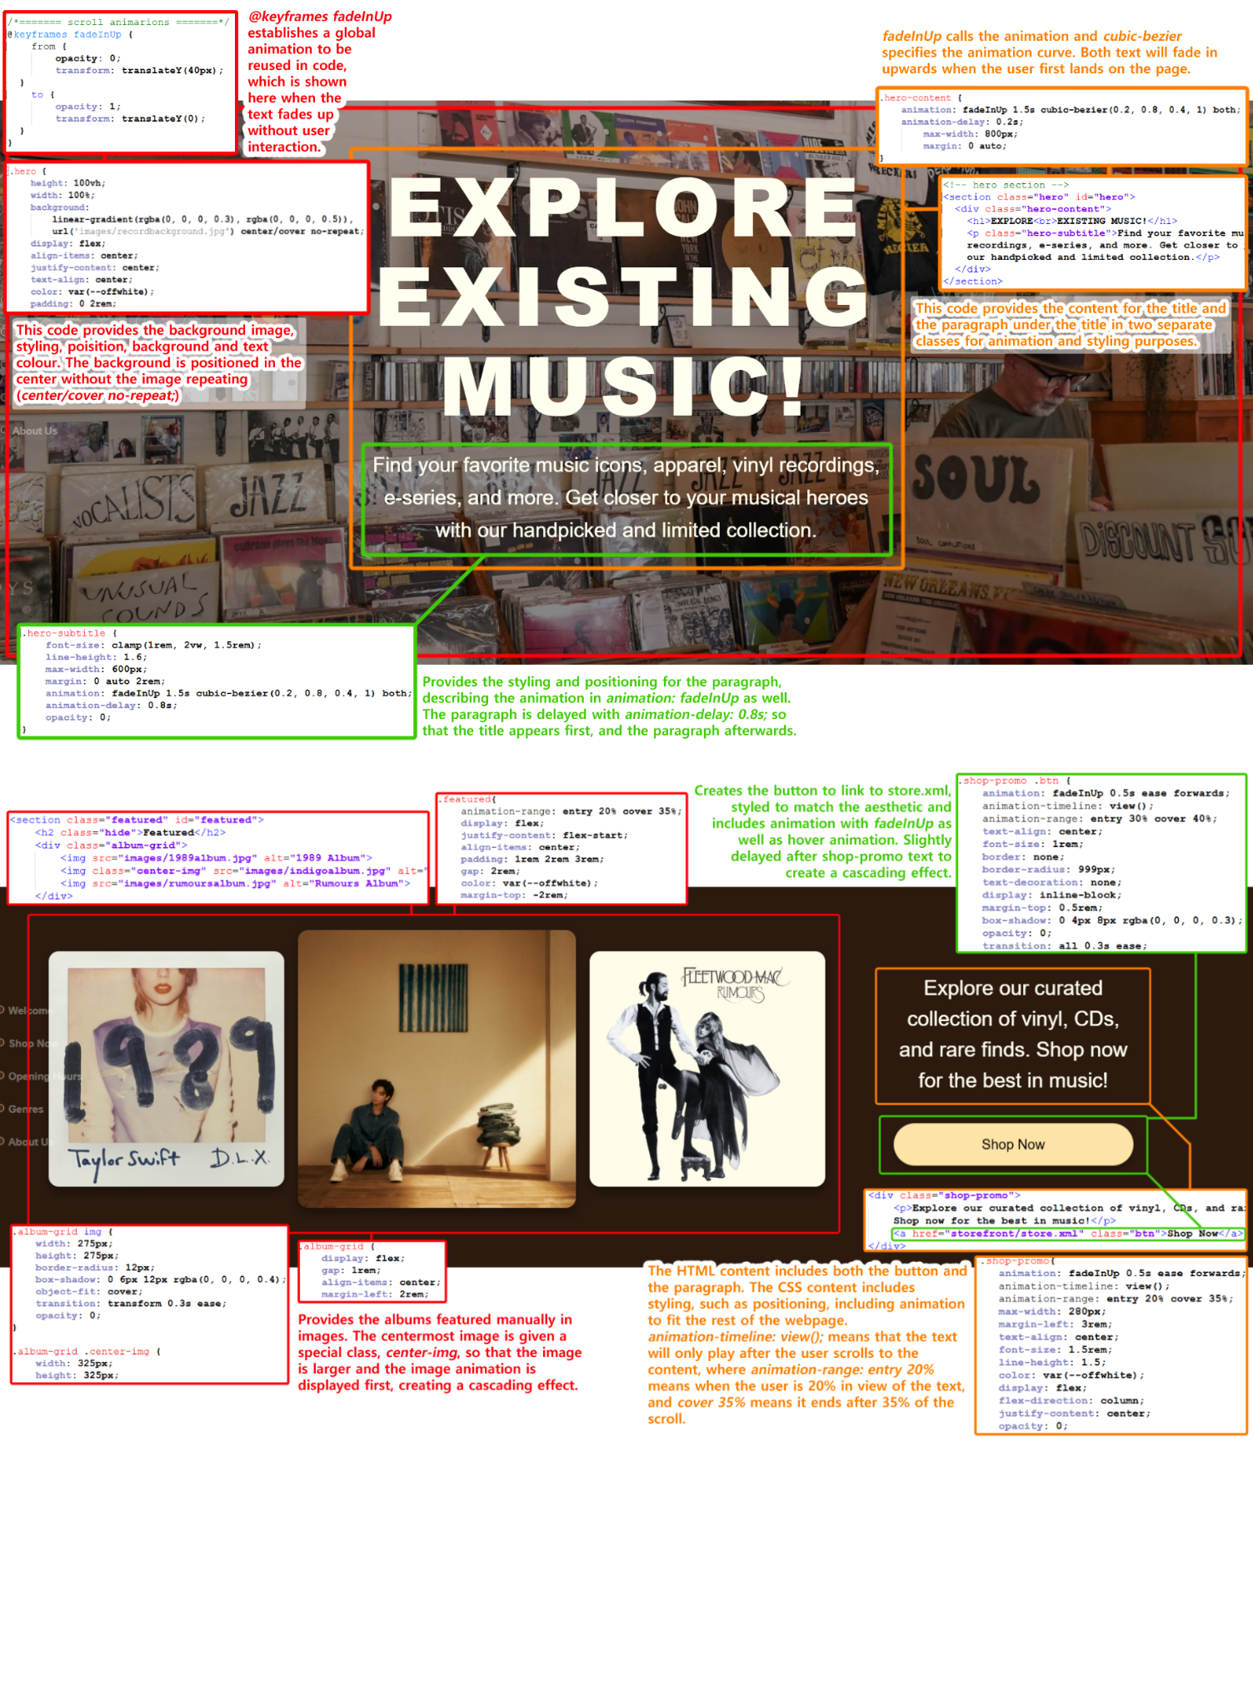

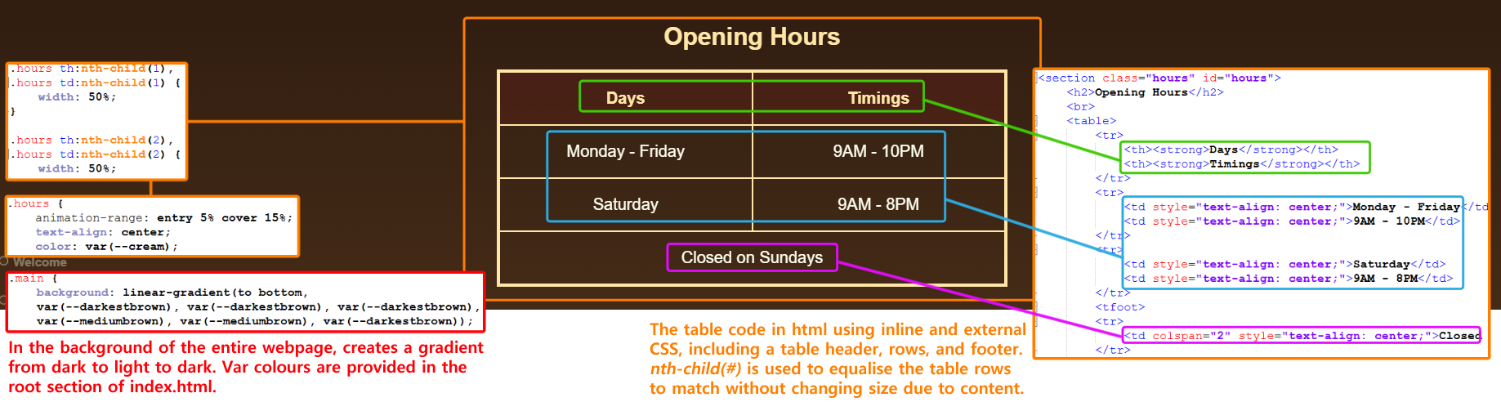

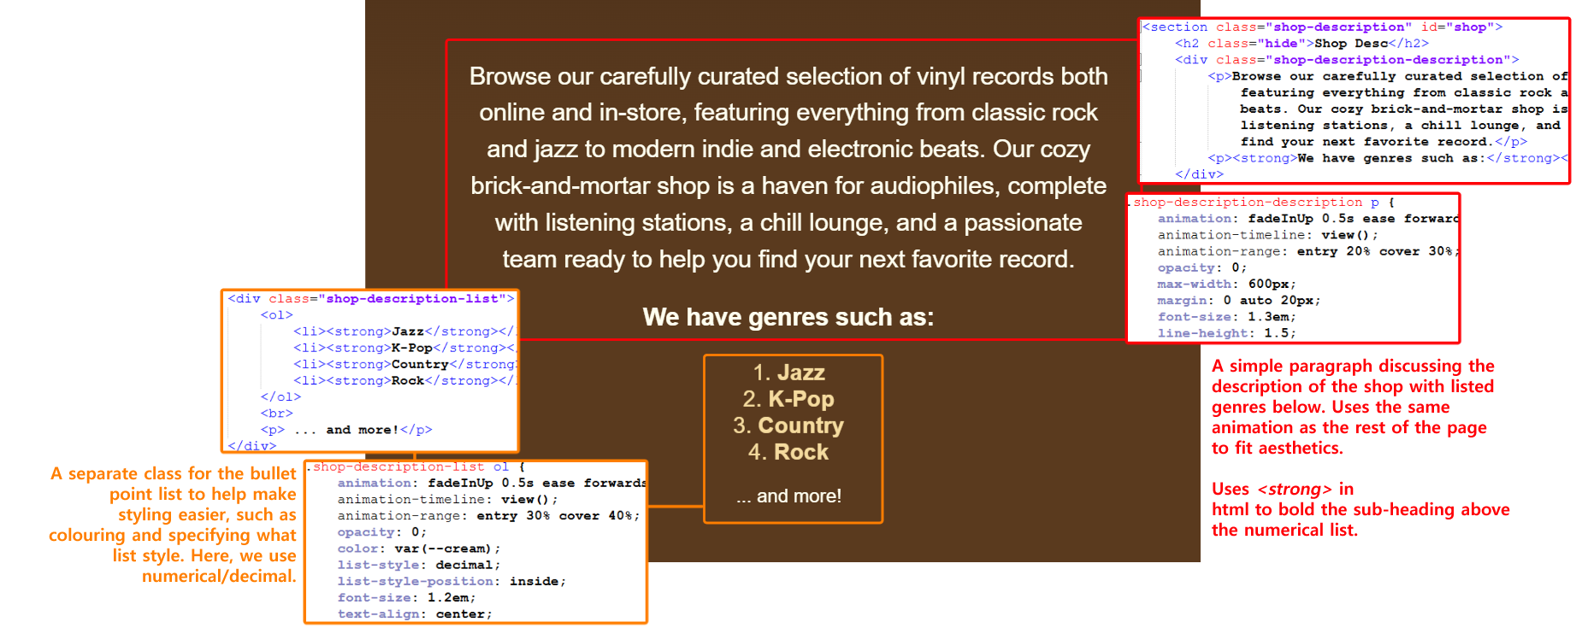

**Fig. Annotated Screenshot of Opening Hours and Shop Description**

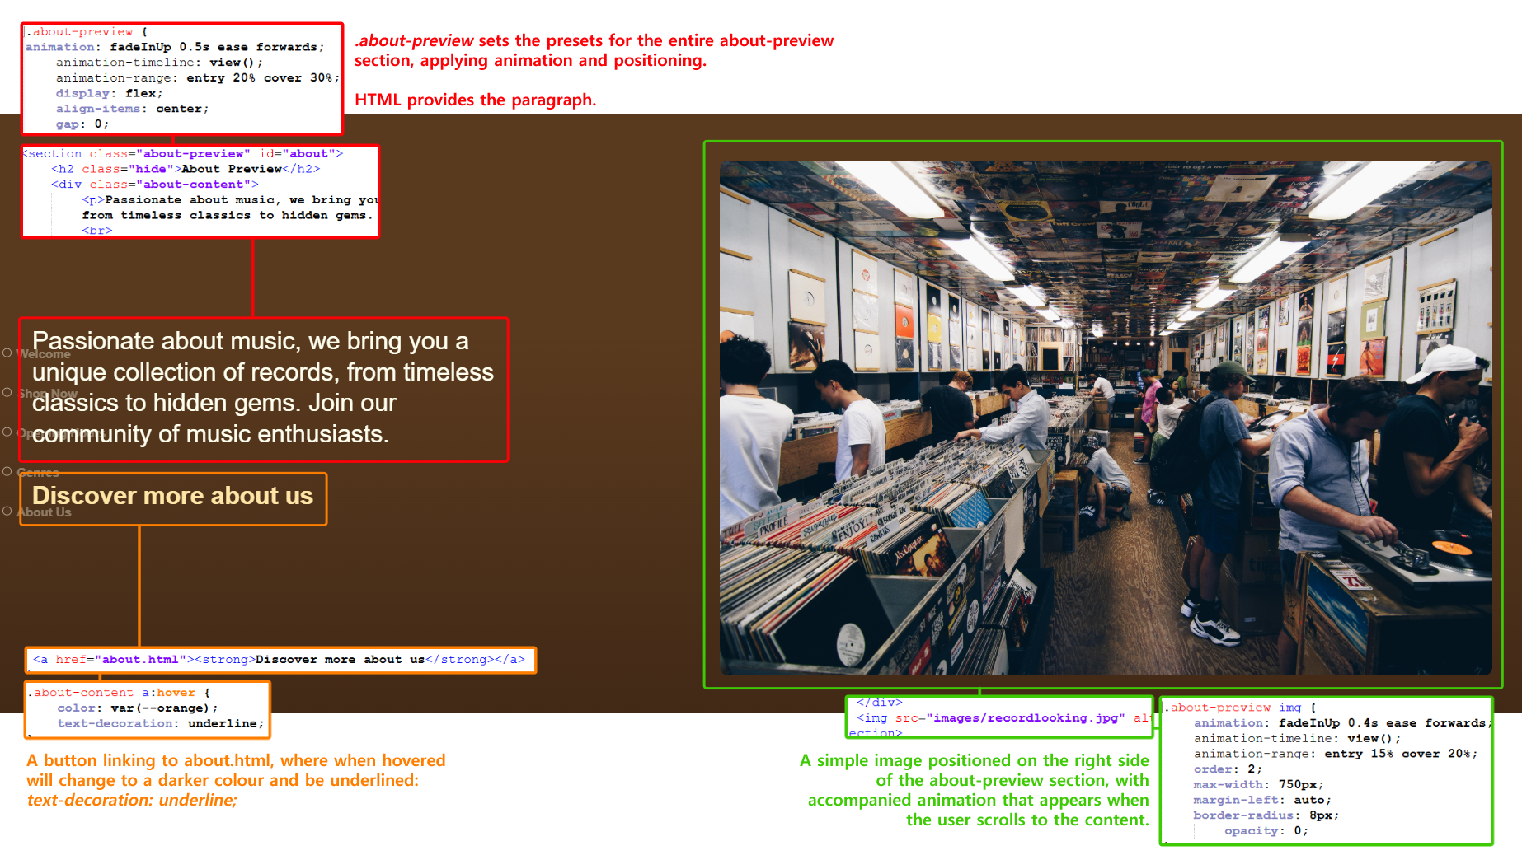

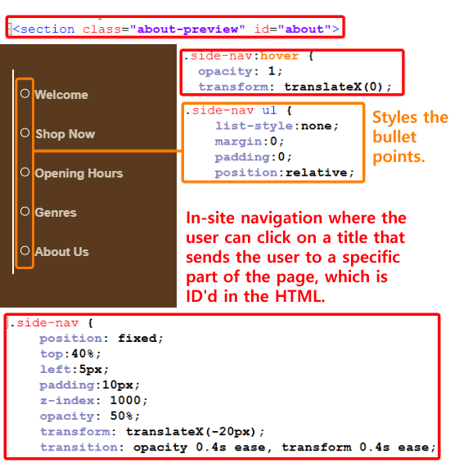

**Fig. Annotated Screenshot of About Preview and Side Navigation Bar**

**Index.html Annotation**

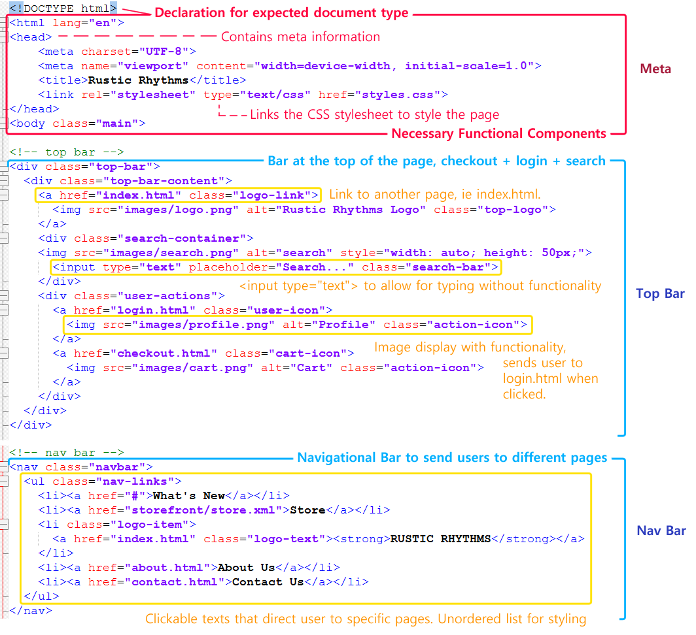

**Fig. Annotated Screenshot of a - index.html**

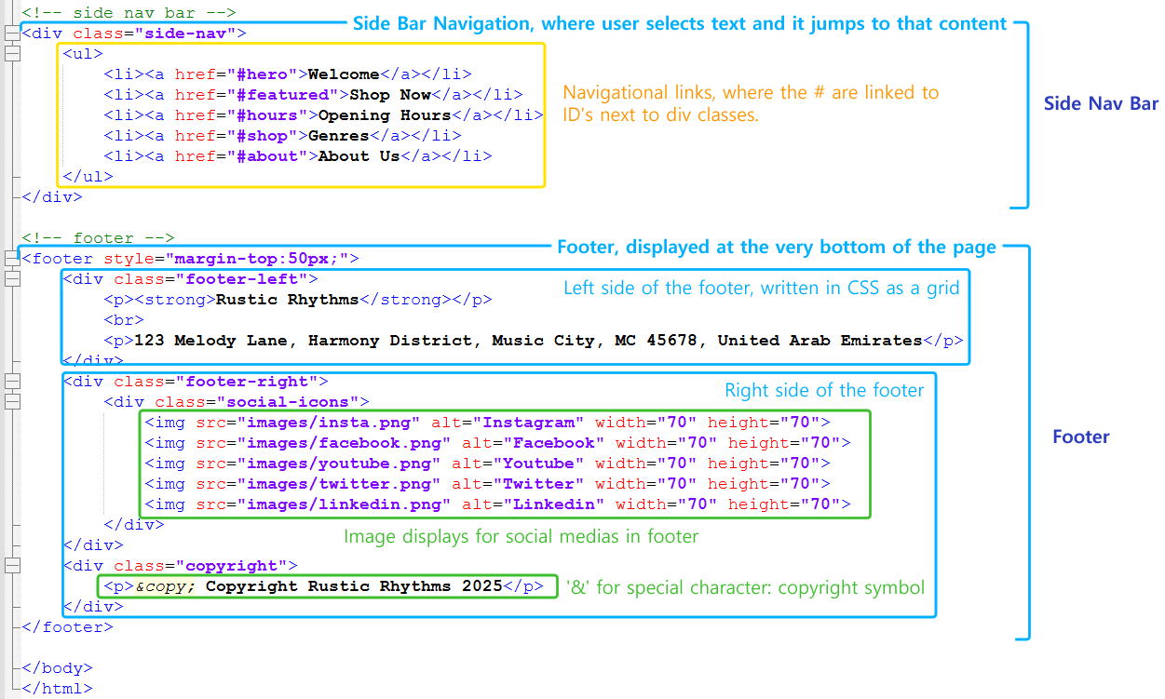

**Fig. Annotated Screenshot of b - index.html**

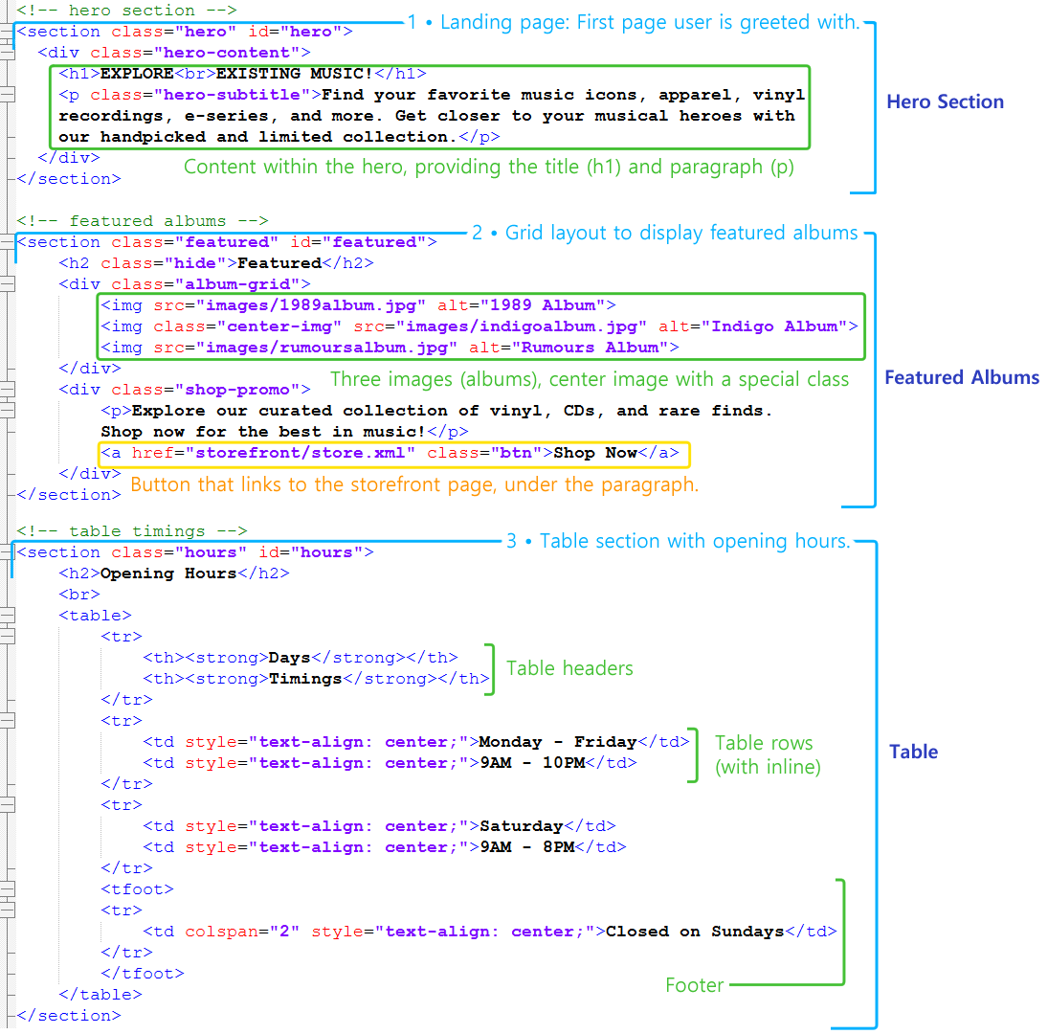

**Fig. Annotated Screenshot of c - index.html**

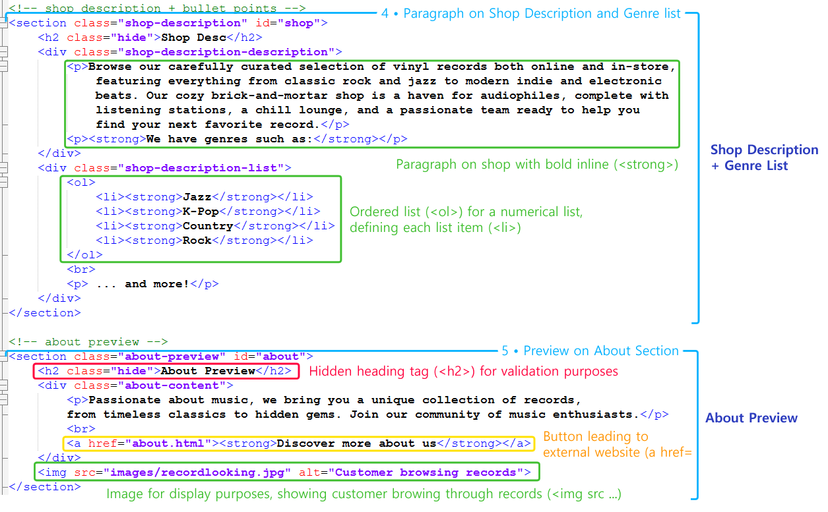

**Fig. Annotated Screenshot of d - index.html**

**About.html**

About.html describes the About Us, featuring our team members' stylised profiles with names and titles, as well as an ‘Our Objective’ section. As it uses external CSS, the structure is much similar to the index.html file, using many of the global elements and attributes.

* The .side-nav on the left quick jumps to “About Us,” “Meet Our Team,” and “Our Objective” sections. It includes hover transitions as well, for subtle increased user experience.
* The About section is the first section the user is greeted with, using .about-section to apply a background image, centered text, and a flexbox layout. It is ID’d with #about.
  + Within this section, a <blockquote> is wrapped in a .quote-container to insert a quote and author with ease.
* The <section class=”team-section”> includes our four team members using .team-members for individual styling, where each member's info is in .team-member. It uses a circular image and role details.
  + The section is wrapped in .team-objective-wrapper, which encases both the team-section and the objective-section for setting the background image easier below both sections.
* The .objective-section discusses our team’s goals and objectives for the records shop, using a simple paragraph with <p> and <h2>.

**About.html Annotation (with Styles.css)**

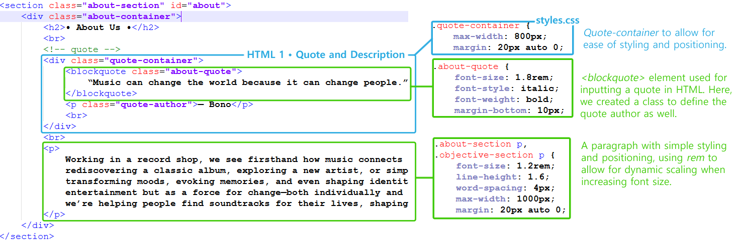

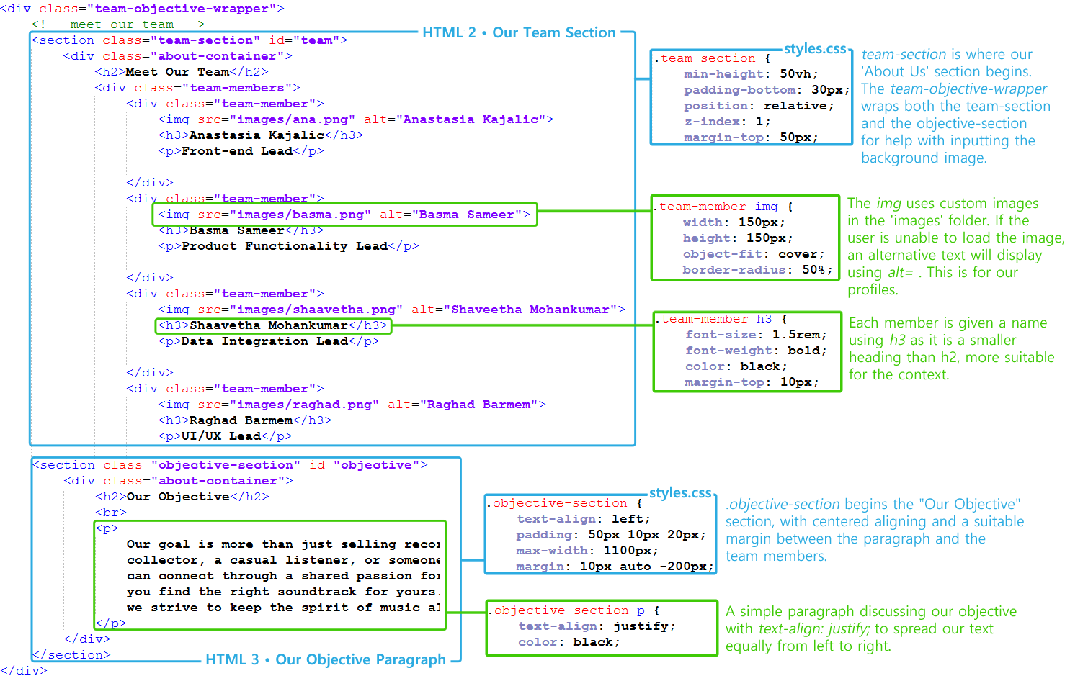

**Contact.html**

Our contact.html is a static page that shows how to contact Rustic Rhythms. It lets users fill out a form to send a message and lists different ways to reach out.

The top bar, main navigation bar, sidebar nav and footer were all styled using internal CSS. These styles were defined within a <style> tag located at the top of the HTML document in the <head> section. This allowed for consistent styling throughout the page.

The contact form and contact information were styled using inline CSS. Styles were applied directly to individual HTML elements via the style attribute. This approach was for precise control of appearance, allowing for quick adjustments.

* The side nav on the left side of the page allowed for users to quickly jump to the form (#FAQ) or contact info section (#contact)
* The contact form section displays a header and welcoming message, four different input fields, a static submit button, and a small prompt to visit the FAQ for additional help
* The contact information section displays Rustic Rhythm’s details like phone number, email address, office address, social media handles, and business hours.

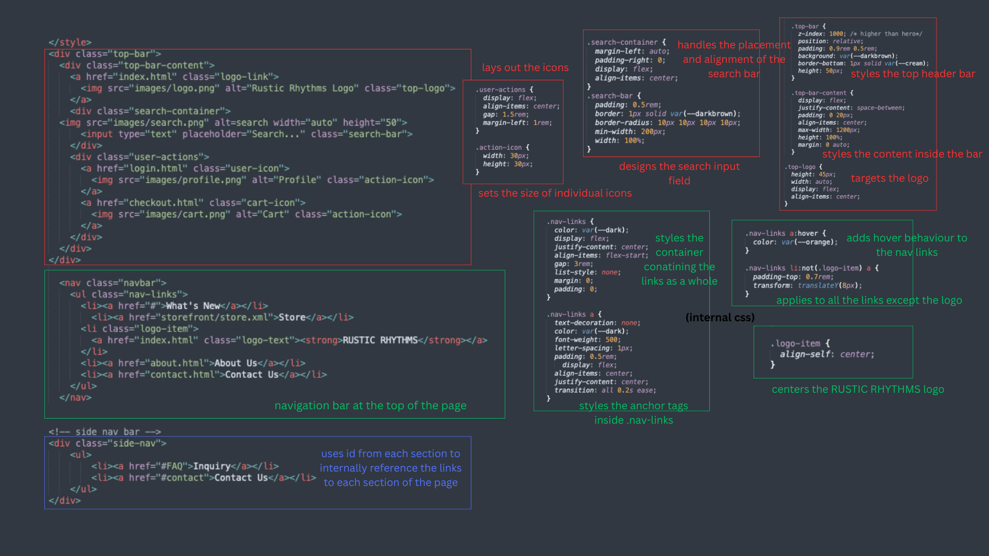

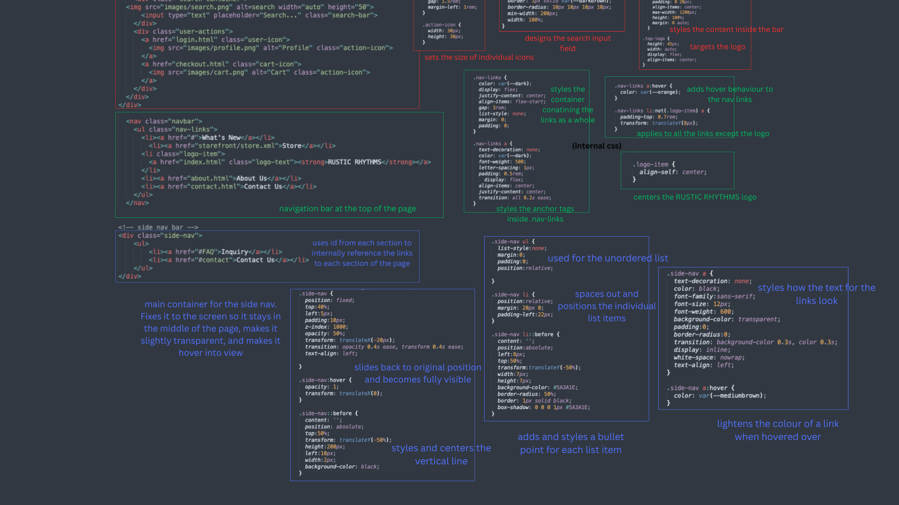

**Fig. Annotated Screenshot of contact.html** 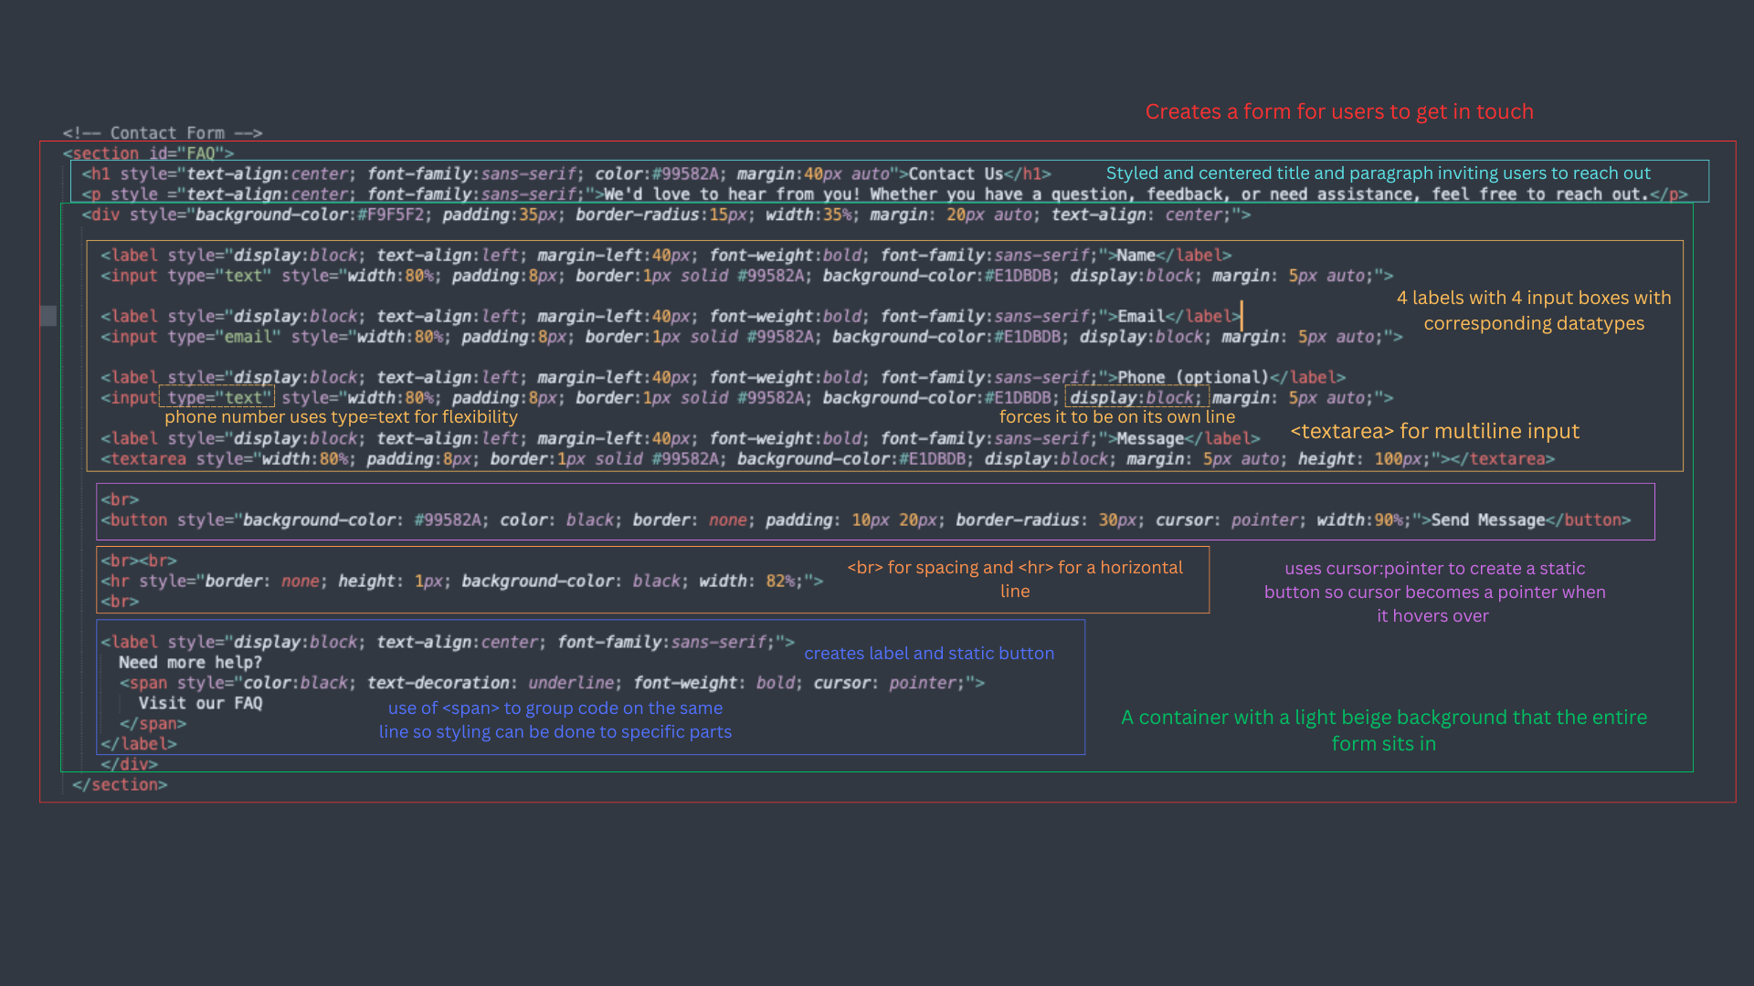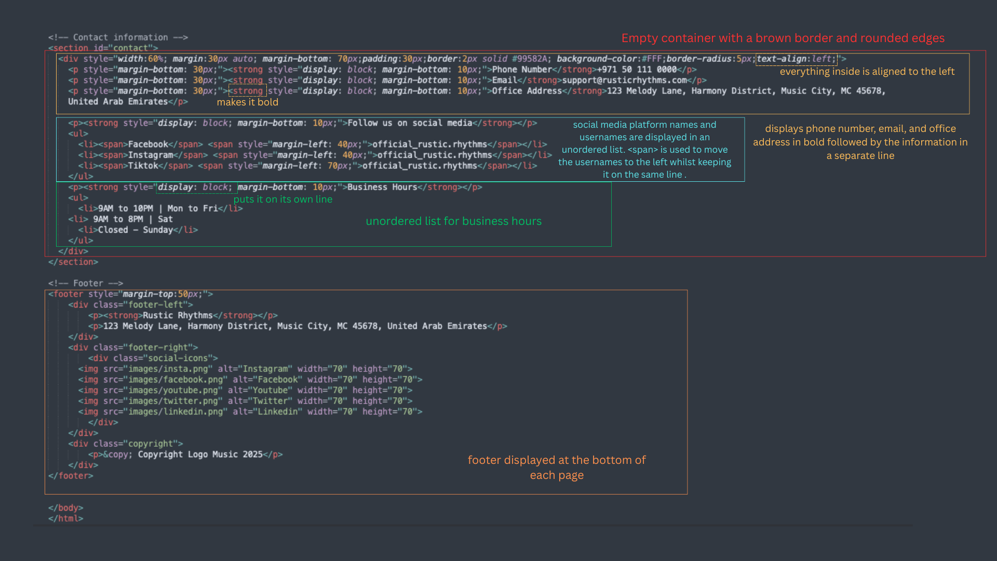

**Login.html**

For the login page, the code was structured using HTML and styled using inline CSS. The inline CSS helped create the preferred styles while structuring the code, which looked simpler to accomplish.

The HTML section of the login is where the users mainly interact with, heading tags were used for the title, label tags to obtain the user’s information such as their email and password. There's also a ‘Remember me’ option, a Login button, a ‘Forgot Password’ link and a ‘Register Now’ button. All of these were maintained by storing them into a <div> container.

To make the login page look appealing and more user friendly, inline CSS styling was used in this case. Many stylings include: background color, paddings, margins, spacing, border radius (for rounding corners) and specific font settings to give the page a soft and modern look. The input field and buttons were also similarly designed.

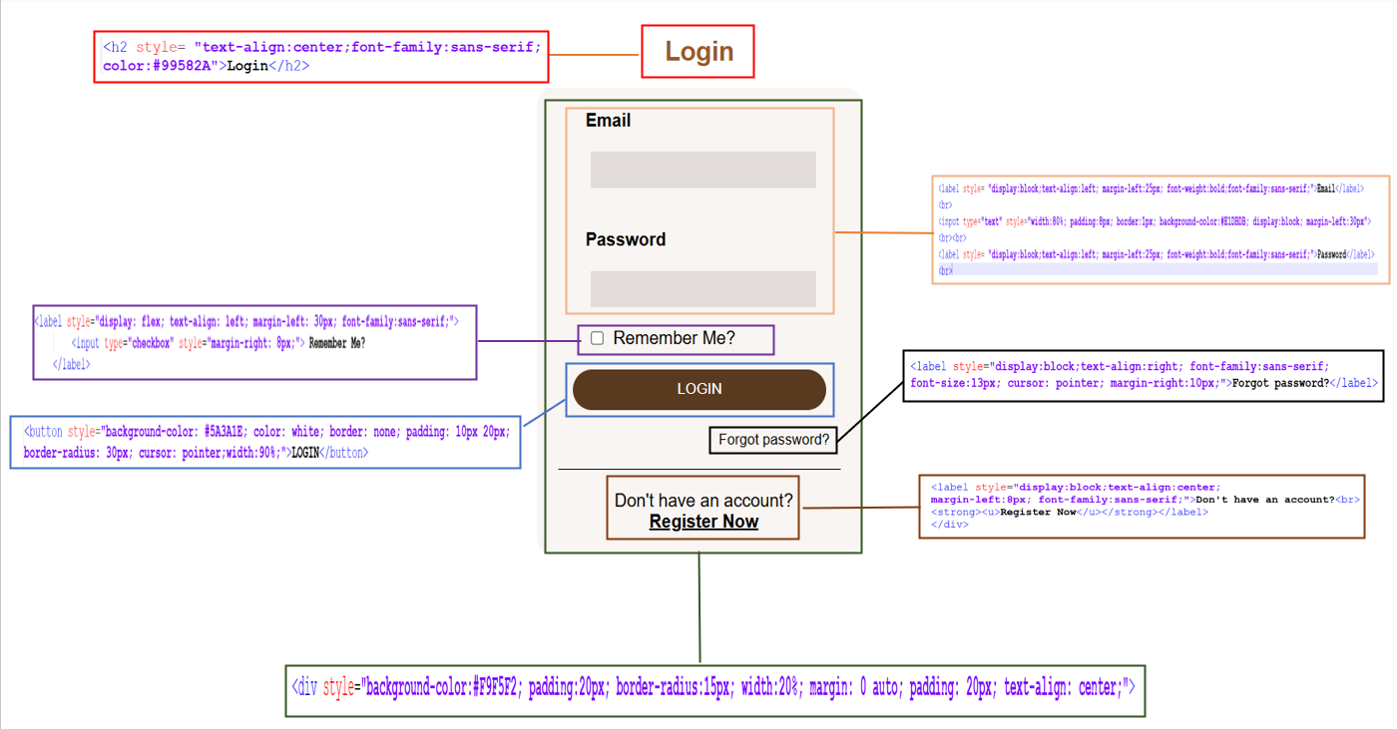

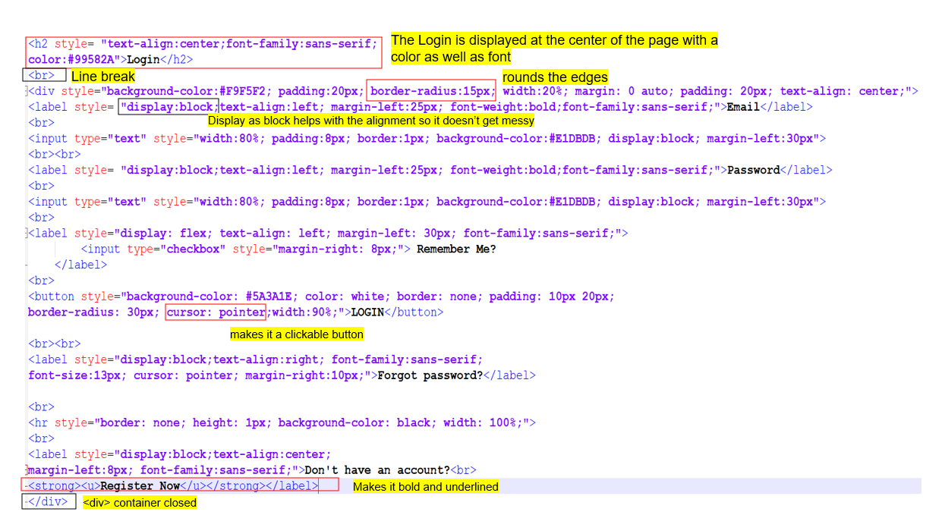

**Fig. Annotated Screenshot of login.html**

**Checkout.html**

The checkout page is designed similarly to the login page, but in this case the user can enter both shipping and payment details. The page was separated into two sections, one for shipping details and the other for payment information and ended with the ‘Complete Order’ button. The content was structured using HTML, using inline CSS as well.

The HTML structure begins with a centered heading for the checkout page, followed by two different sections: one for shipping information and the other for payment information. For each area, a <div> container was used, and within it, there are input fields where users can fill out their information such as their first name, last name, telephone, email, etc. Labels are provided next to these input fields to make it more user friendly. Similarly, the second portion has the same content, except it is designed for payment information.

The checkout page was designed with inline CSS; a soft background color was used for both divisions, and the edges were rounded using border radius, the input fields were also given a light shade. All texts are spaced and aligned evenly. Finally, the button stands out with a bold background color and rounded borders.

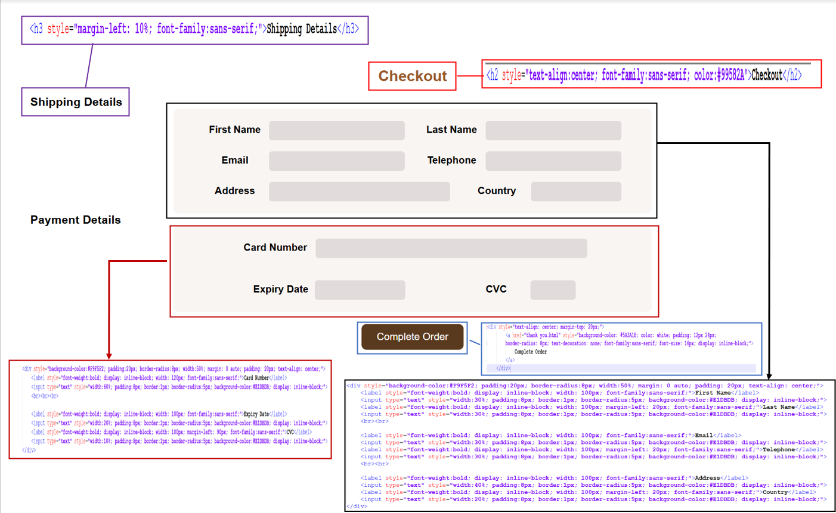

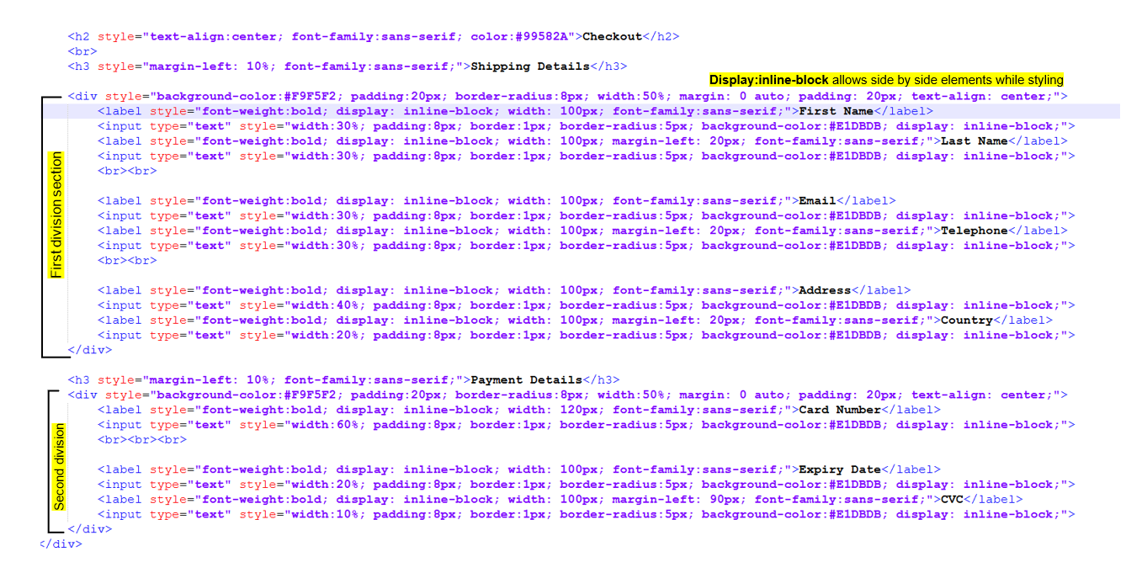

**Fig. Annotated Screenshot of checkout.html**

**Thank you.html**

The ‘Thank You’ page appears immediately after the “Complete Order” button is clicked, confirming that the payment was successful and thanking the customer for their purchase. An image is displayed at the center of the page, followed by a short message and confirming the order. Simple font styles and colors were used to keep the page clean and consistent with the overall design of the website.

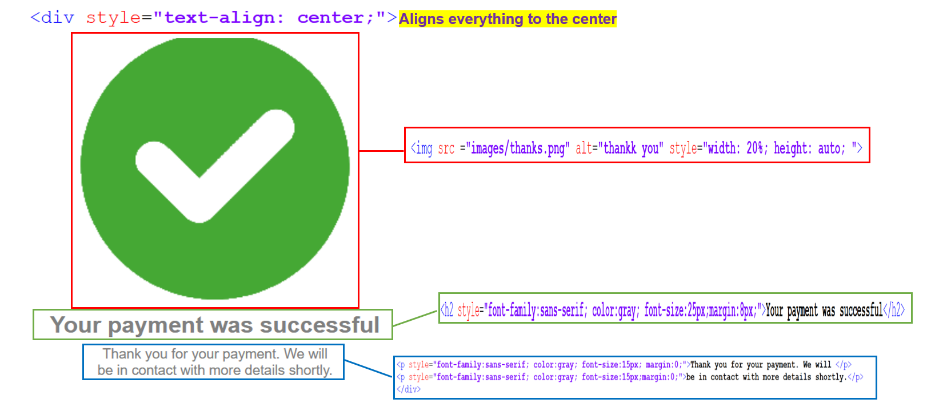

**Fig. Annotated Screenshot of thank you.html**

*2.1. CSS - Explanation of Code*

**Store.xsl**

A combination of external and inline CSS has been used for this file. In the below figures, each coloured box categorizes the declaration blocks by its purpose. Illustrated in the output is where the styling and format of each is applied. The blue boxes define the area the containers occupy in the page, and pink boxes define layout parameters and typography. While, red boxes have the same functionalities but are solely for listing of genre names with hover effect applied.

**External CSS**

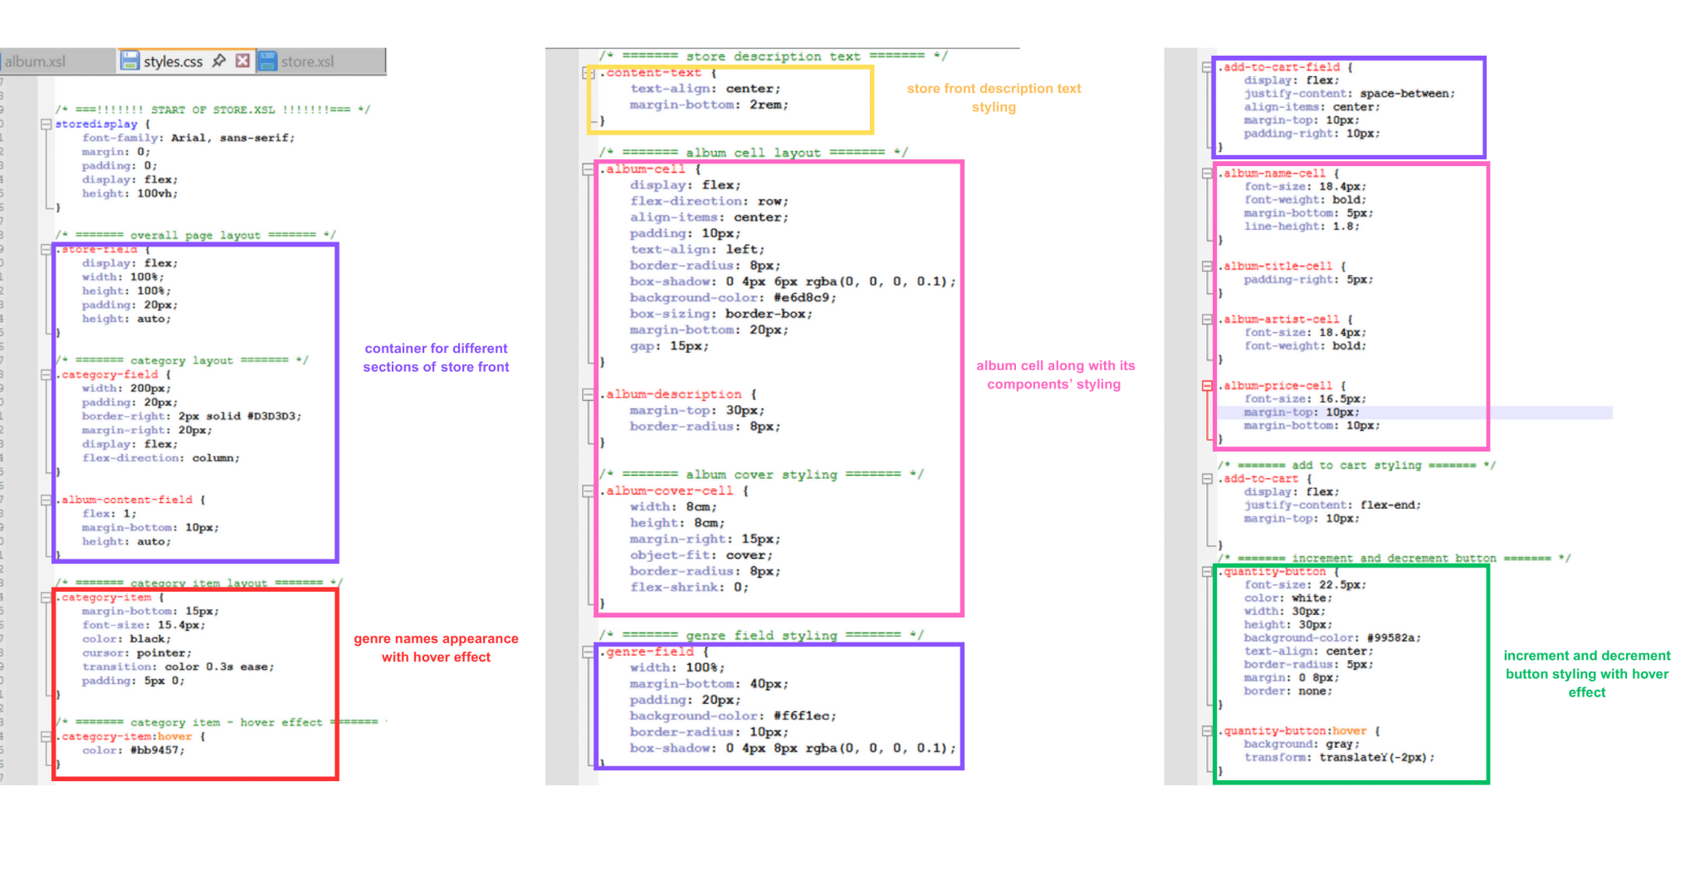

**Inline CSS**



**Fig. Annotated Screenshot of store.xsl**

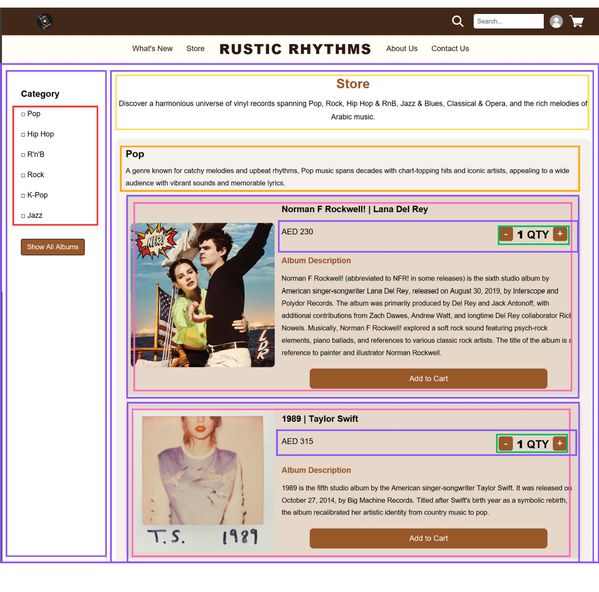

**Fig. Output of store.xsl displaying the positioning of CSS styles on the layout**

**Section 3: XML - Extensible Markup Language**

*3.1. XML Schema*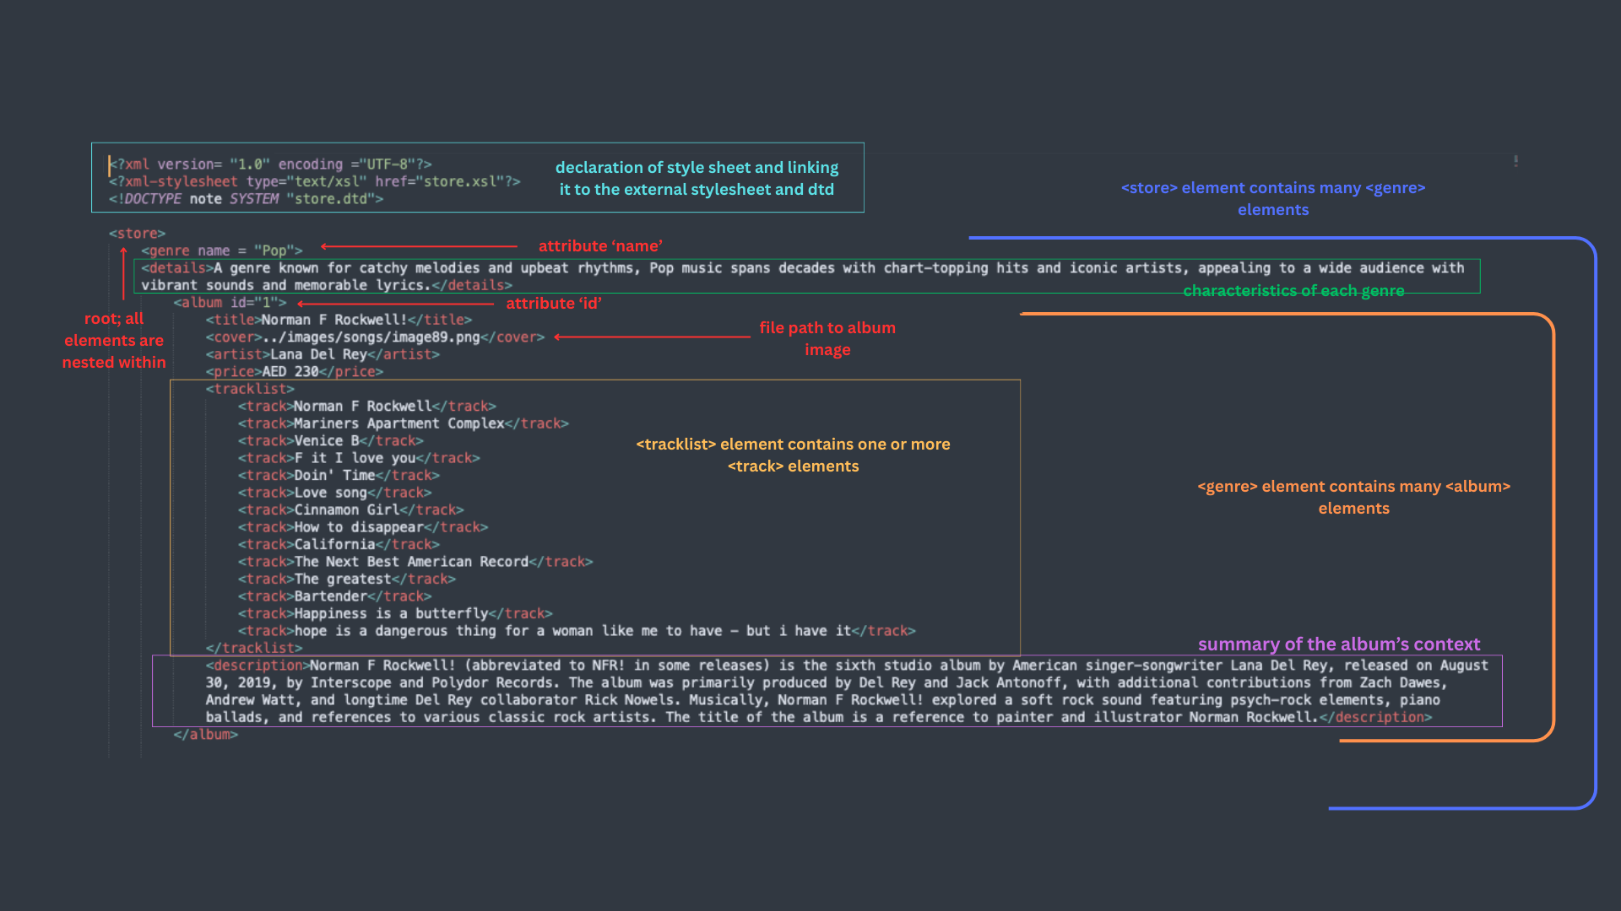

**Fig. Annotated Screenshot of One Album in store.xml**

*3.2. Explanation of Code*

Store.xml was designed to store all the essential information needed for our storefront, ensuring the data is organized and easily accessible for display using XSL. The defined rules on store.dtd were followed by this structure to ensure the data is well-formed and consistent.

The root element **<store>** encapsulates a collection of **<genre>** elements with an identifier; name attribute. Each **<genre>** element contains one or more **<album>** elements with an uniquely identifying id attribute. Albums are described by a set of elements including the **<title>**, **<cover>**, **<artist>**, **<price>**, **<tracklist>** and **<description>**. Each **<tracklist>** element, a child of **<album>**, is a container for **<track>** elements, which represent individual audio tracks.

**Section 4: Validation with DTD**

The XML instance hierarchy was created first to provide a visualization of the desired structure for our store.dtd file. It helped define the parent-child relationships between elements and how they should be nested within one another.

[r] indicates the root node. The **store[r]** element represents the entire music store, serving as the top-level container for all the data.

[c] indicates a container element which holds a collection of one or more items. All container elements include child nodes. **genre[c]+** represents the various genres available, with each genre containing multiple albums.

The elements **details**, **title**, **cover**, **artist**, **price**, **track**, and **description** were defined to contain parsed character data (#PCDATA), meaning they can hold any type of text content.

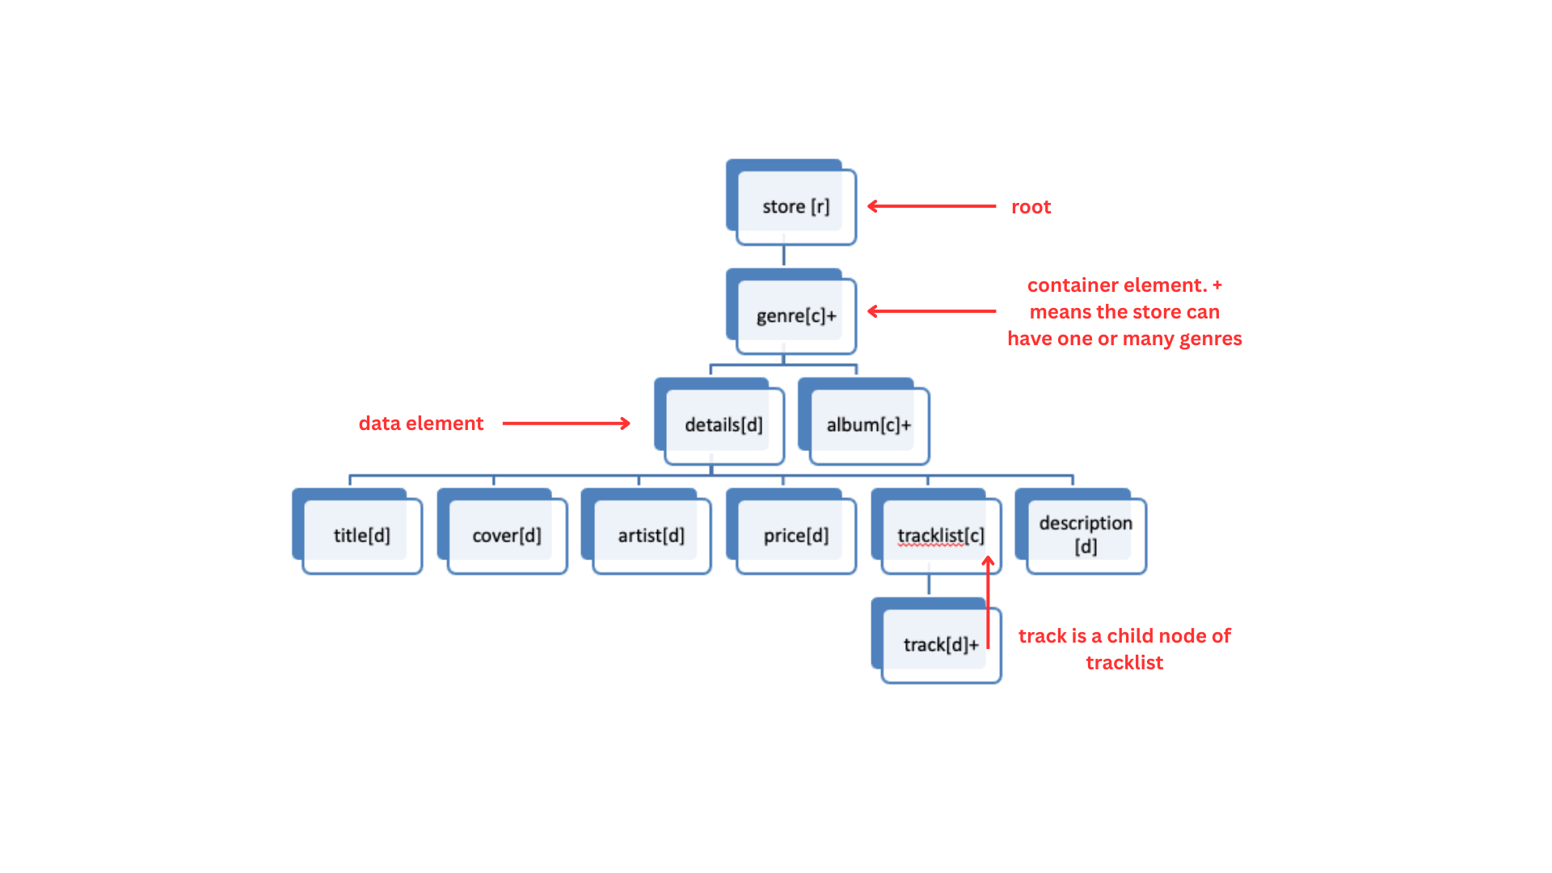

**Fig. XML Tree Structure of store.xml and album.xml**

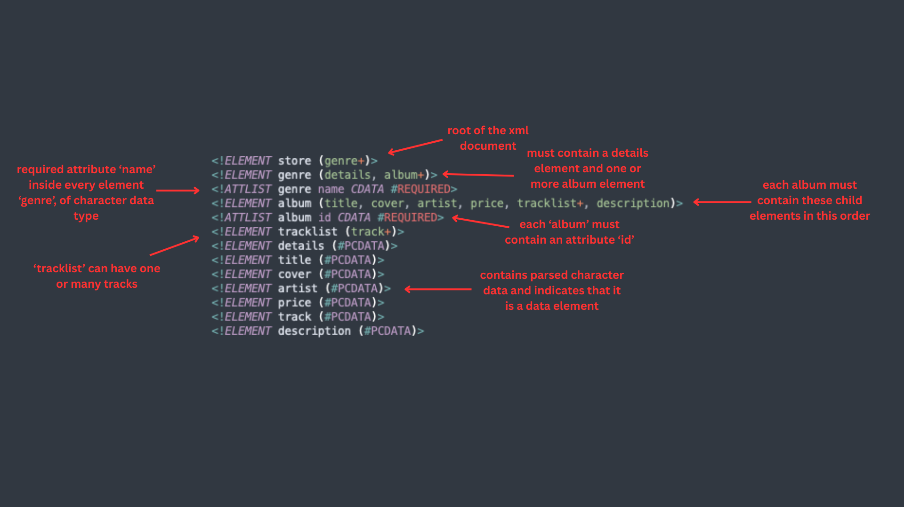

**Fig. Annotated Screenshot of store.dtd**

* **Namespace**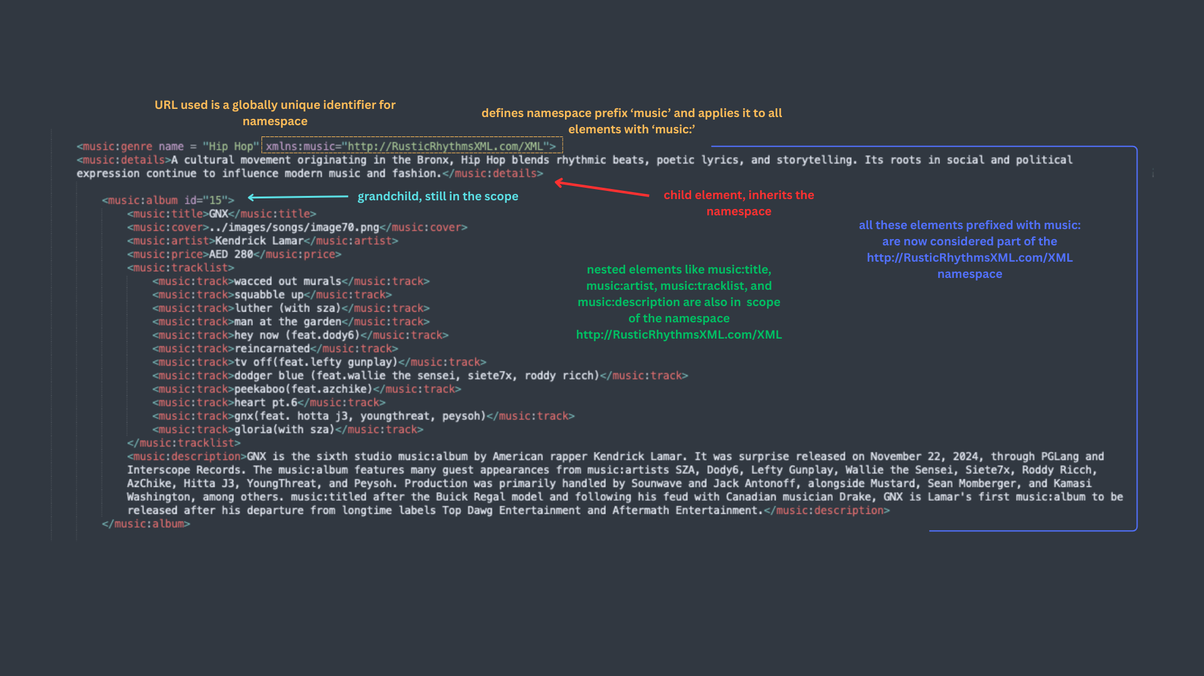

**Fig. Annotated Screenshot of album.xml - namespace**

XML Namespace is a way to avoid name conflicts in XML documents with a unique identifier. They are used to distinguish elements that might have the same name but belong to different contexts. Xmlns:music specifies the URL [http://RusticRhythmsXML.com/XML](http://rusticrhythmsxml.com/XML) (doesn’t have to point to an actual resource) as the unique identifier. The namespace has been associated with the prefix ‘music:’ in album.xml. It is applied directly to music:genre where it was declared and all the elements under it inherit the same namespace as they are within the scope of declaration and use the ‘music:’ prefix.

Therefore, when transforming the data from XML to HTML using XSLT, the elements are referenced using ‘music:’ prefix.

**Section 5: Transformation**

*5.1. XSLT - Explanation of Code*

Both store.xsl and album.xsl begin with the mandatory format of XML and XSLT declaration, specification of output format and settings of transformed documents followed by the root template [1]. Without them, improper formatting may occur and certain commands may not be recognised. Subsequently, the HTML structure including <head> and <body> tag is defined, where XSLT commands are implemented to display the XML data in XHTML.

**xsl: for-each** and **xsl: value-of** are the XSL commands used to extract the album details such as the album name, cover, artist, price, tracklist and description from the album.xml and store.xml file to display in their respective XHTML file.

* **xsl: for-each**: it iterates over a specific node set in XML and the instructions within this loop are applied to each. Eg. to loop through each <genre> and <album> element in the XML file.
* **xsl: value-of**: it extracts a value of a selected node and inserts it into the transformed output. Eg. to extract the value of <title> of the current album and insert it into the <td> cell of the XHTML file [4].
* XSLT to display the album list in a tabular format

The main objective of this transformation is to retrieve specific data from album.xsl and display it in a tabular structure. By using <table> tag and combining it with XSLT commands, data is extracted and organised into rows and columns. Additionally, CSS styling enhances the presentation.

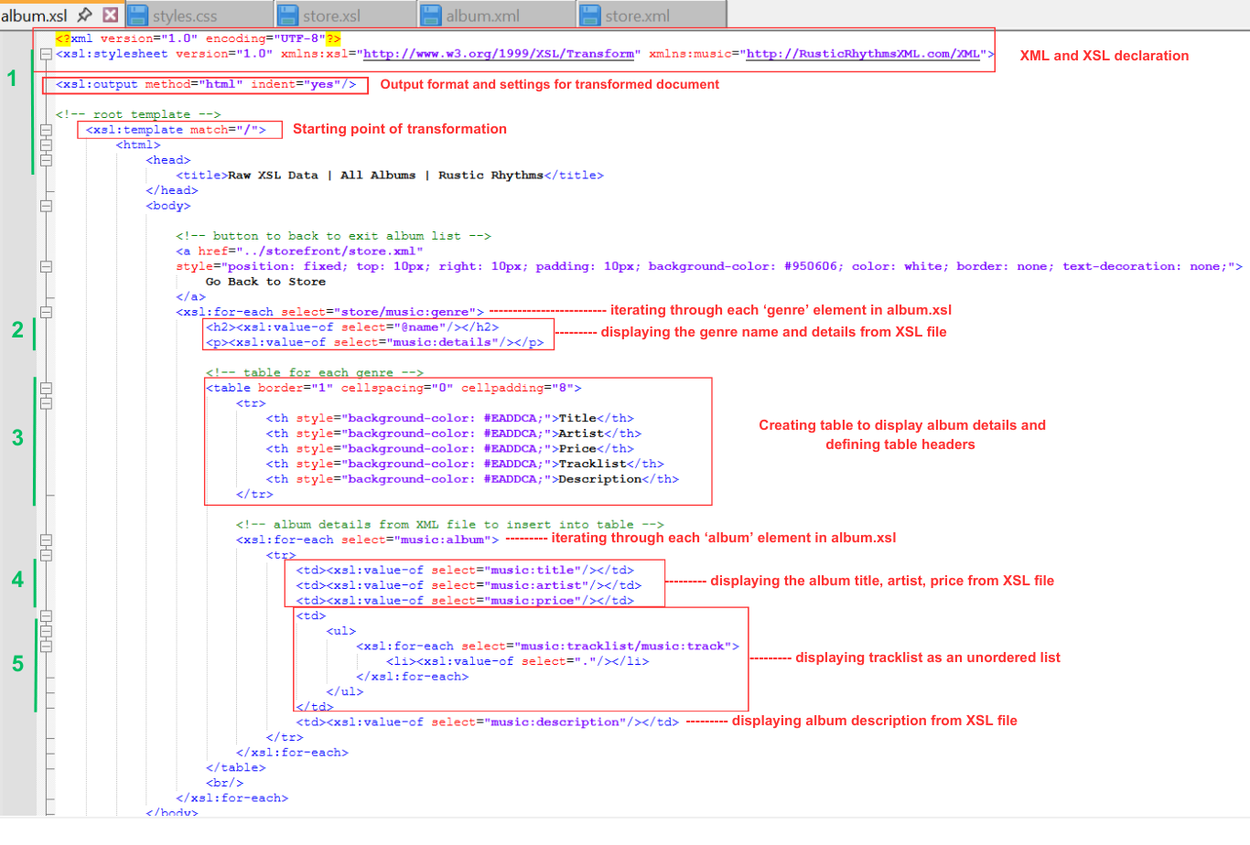

**Fig. Annotated Screenshot of album.xsl**

* XSLT to display the store page

The main objective of this transformation is to display the wide selection of albums by their genres. Each would have album details from the store.xml displayed as per external CSS styling. XSLT achieves this by extracting needed data from store.xml and organising it within the HTML structure. Once the customer finds an item of interest, clicking the add to cart button takes them to the checkout.html for purchase.

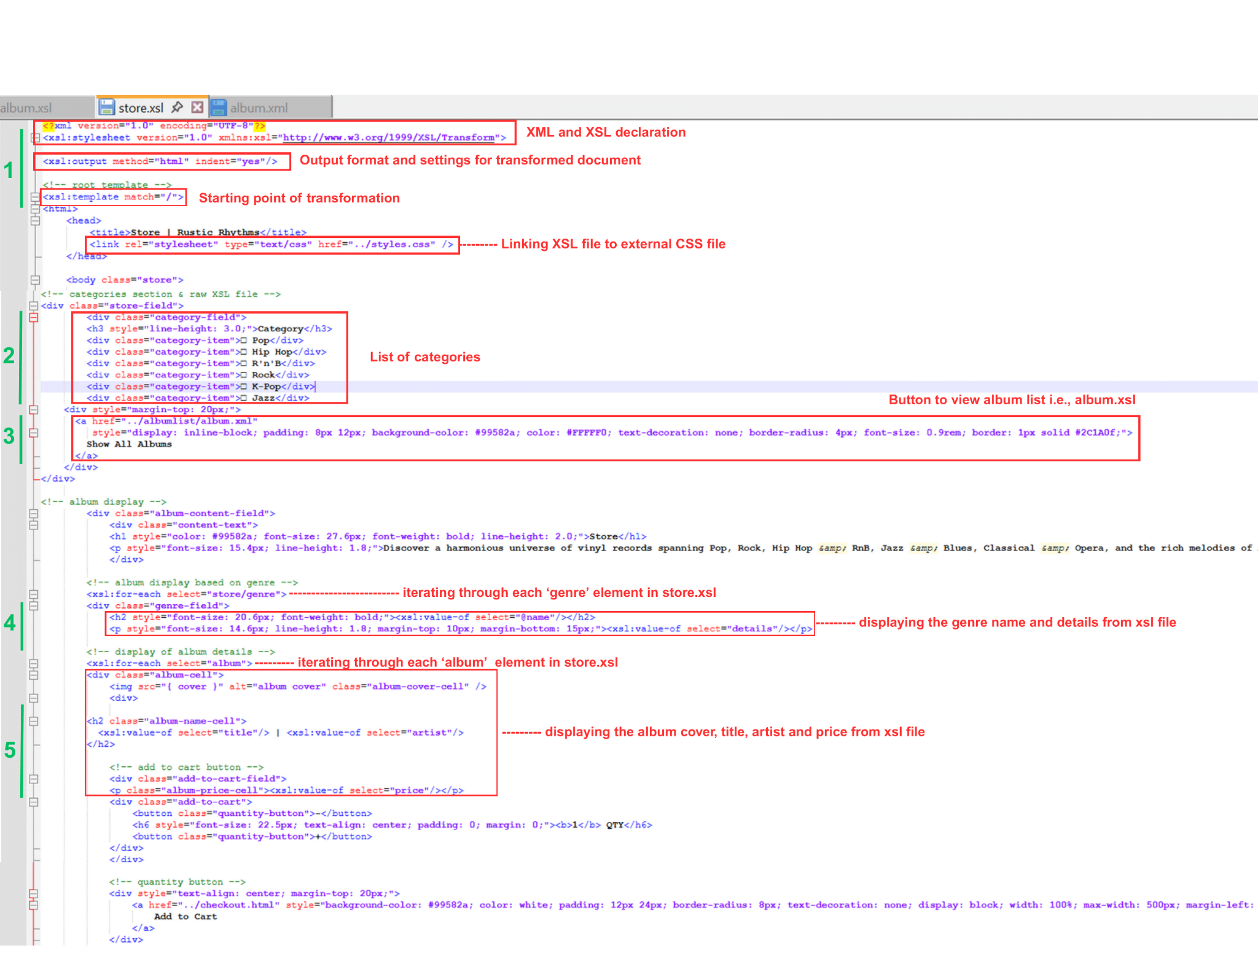

**Fig. Annotated Screenshot of store.xsl**

*5.2. Data Transformation - XML to XHTML*

The transformation of XML data into XHTML is implemented by using XSLT. The initial process involves selection of required data from the XML file using XSLT commands. It iterates over the nodes and extracts its contents in order to present data as HTML structure with appropriate tags.

The xsl: output command ensures the data transformation and the formatted content retains its indentation. By combining XSLT, XML and CSS styling, the result is a XHTML page that displays album details in a tabular structure and the store front page categorising albums by their genres.

This approach of presenting data rather than hard coding details in a HTML format offers significant advantages, including easier maintenance and updates of XML data, and reducing redundant and duplicate codes. It also ensures that the presentation is both consistent and adaptable to various needs.

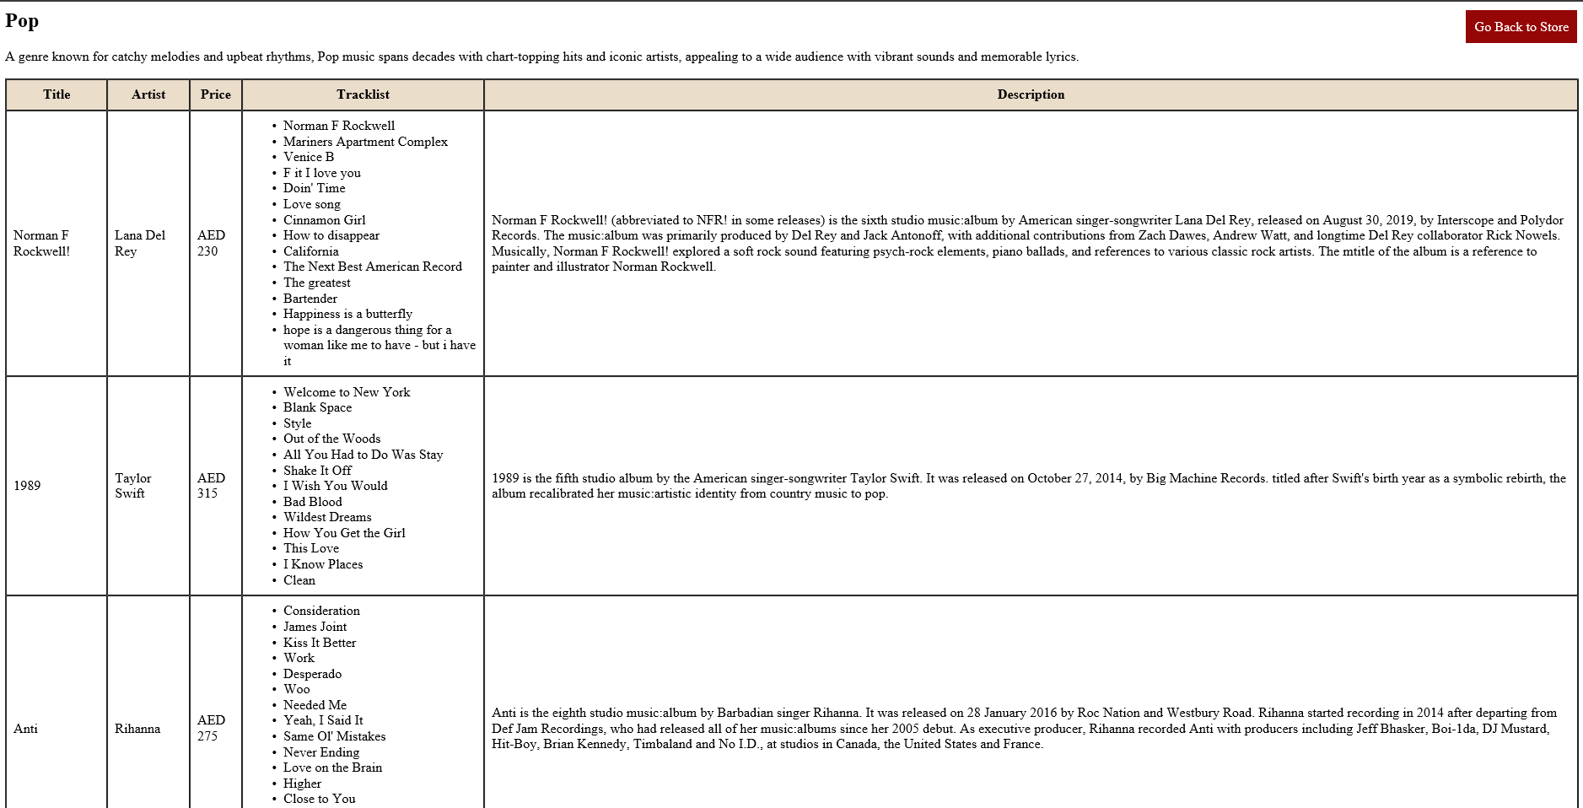

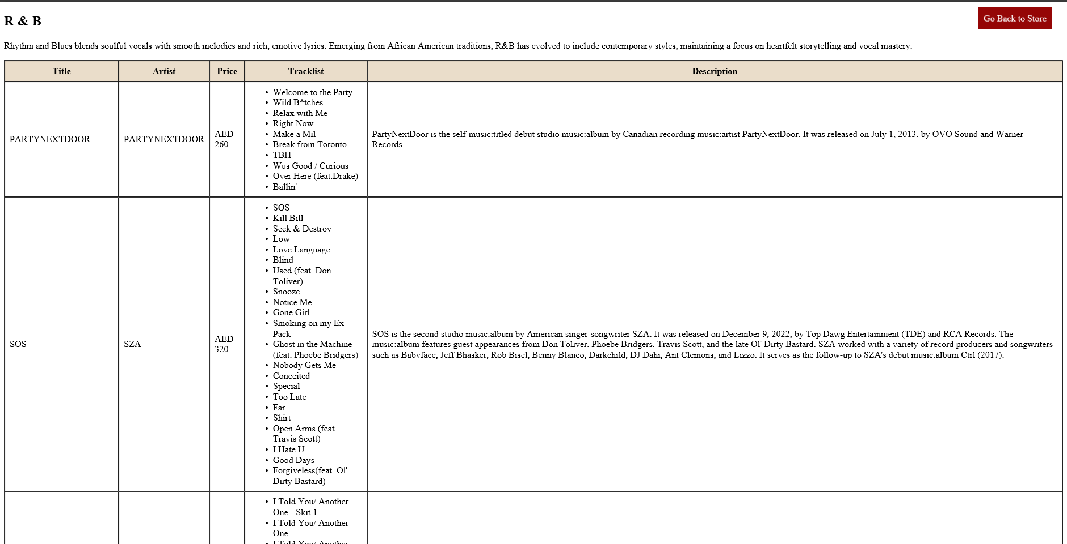

**Fig. Output of album.xsl**

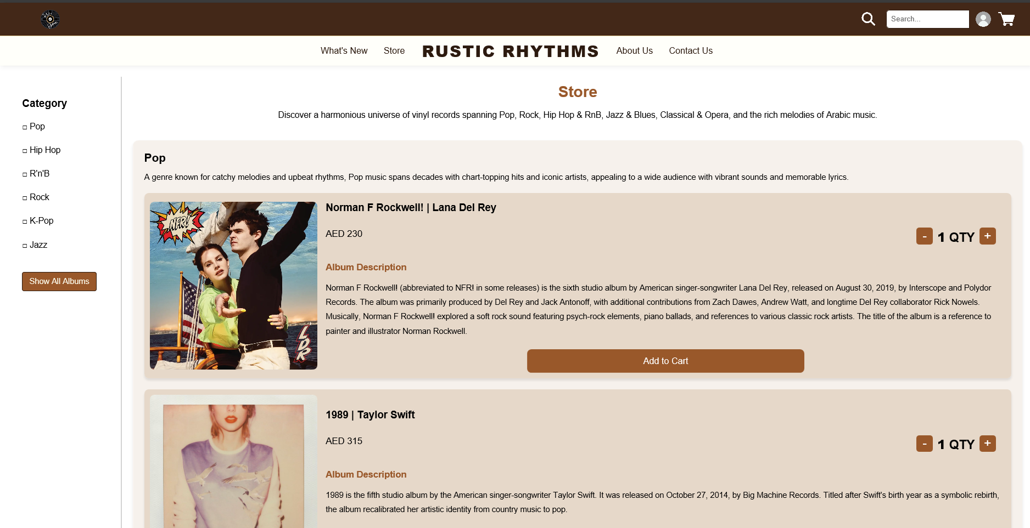

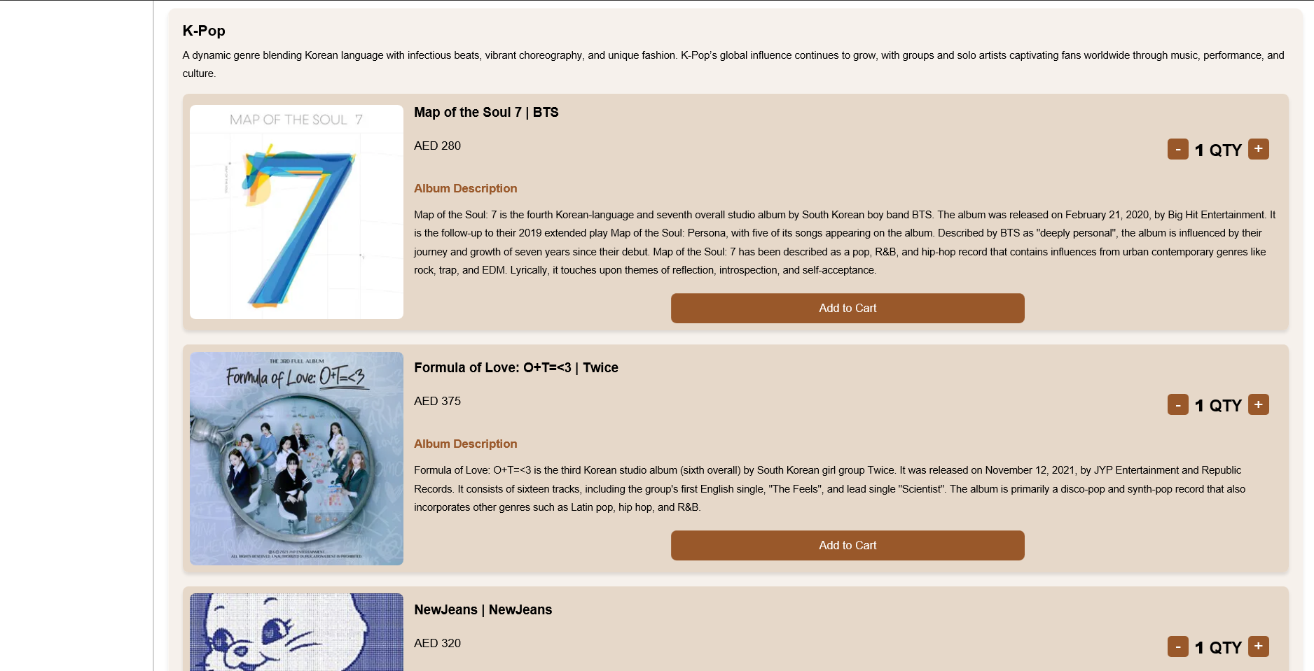

**Fig. Output of store.xsl**

**Section 6: Validation**

*6.1. XML Validation*

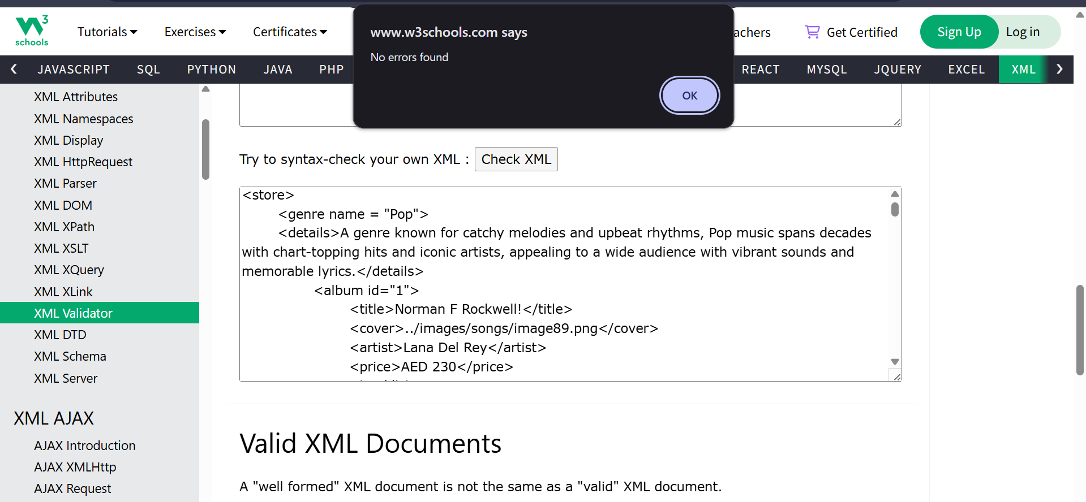

**Fig. Validation for store.xml**

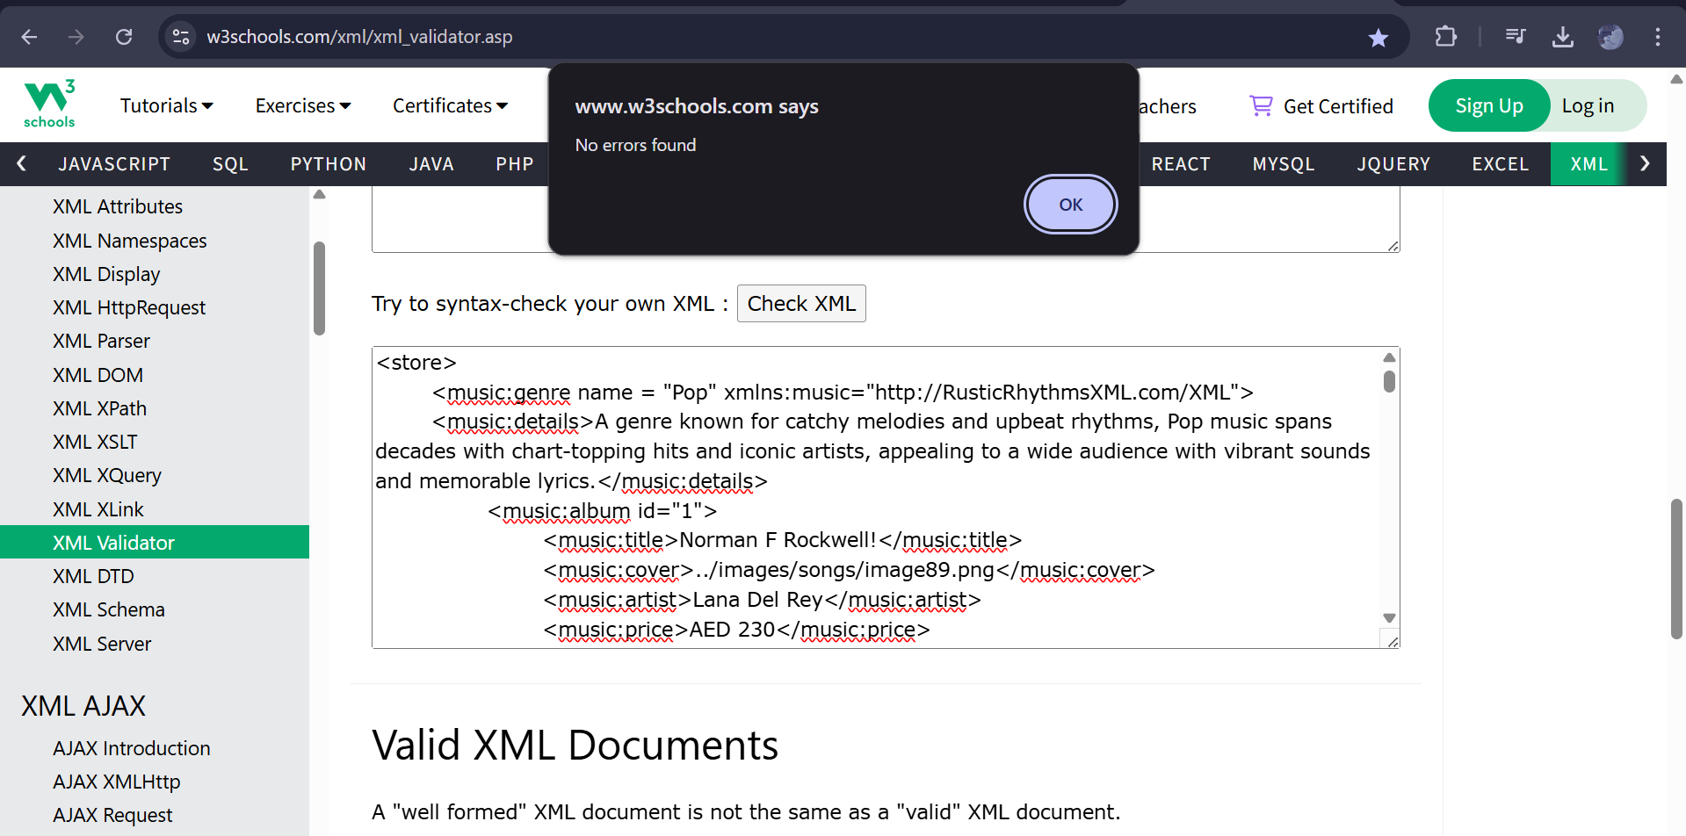

**Fig. Validation for album.xml**

*6.2. HTML Validation*

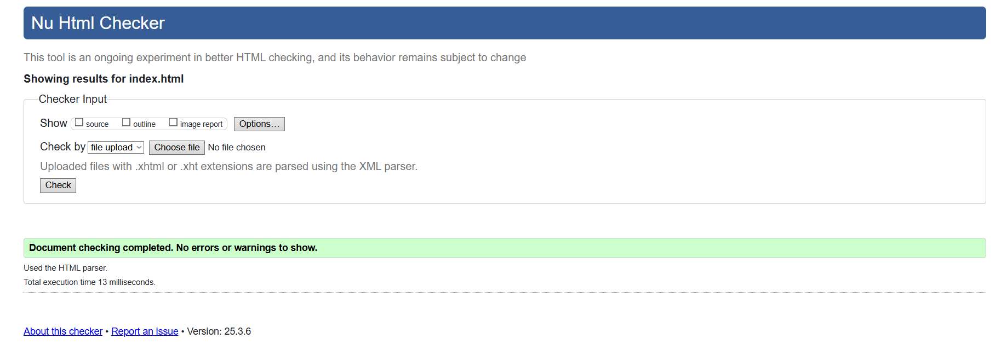

**Fig. Validation for index.html**

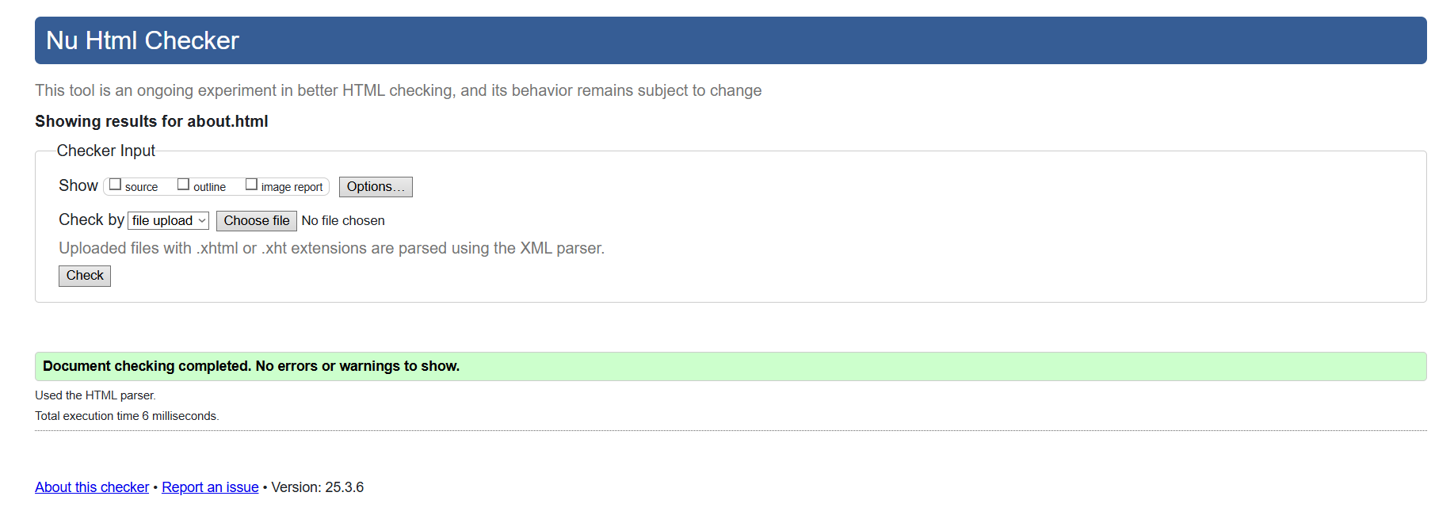

**Fig. Validation for about.html**

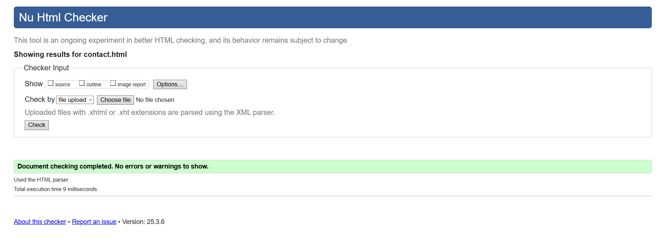

**Fig. Validation for contact.html**

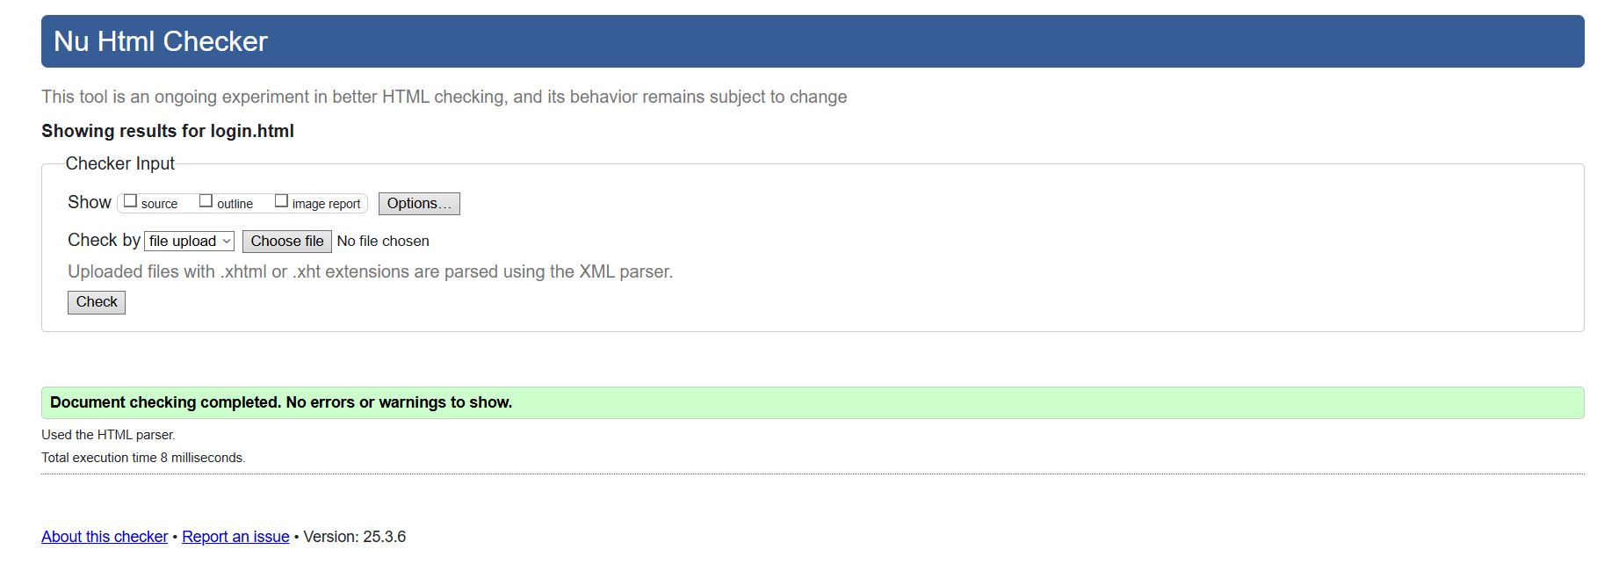

**Fig. Validation for login.html**

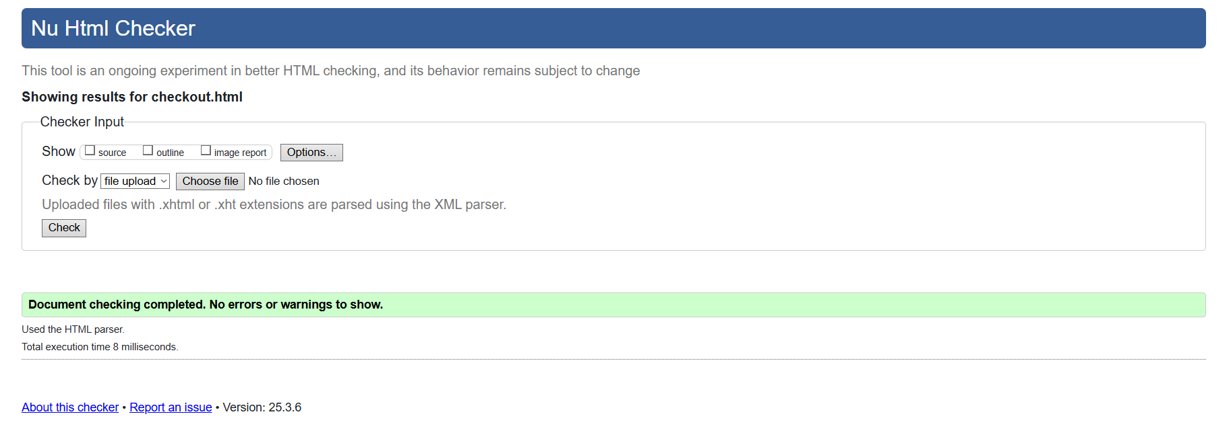

**Fig. Validation for checkout.html**

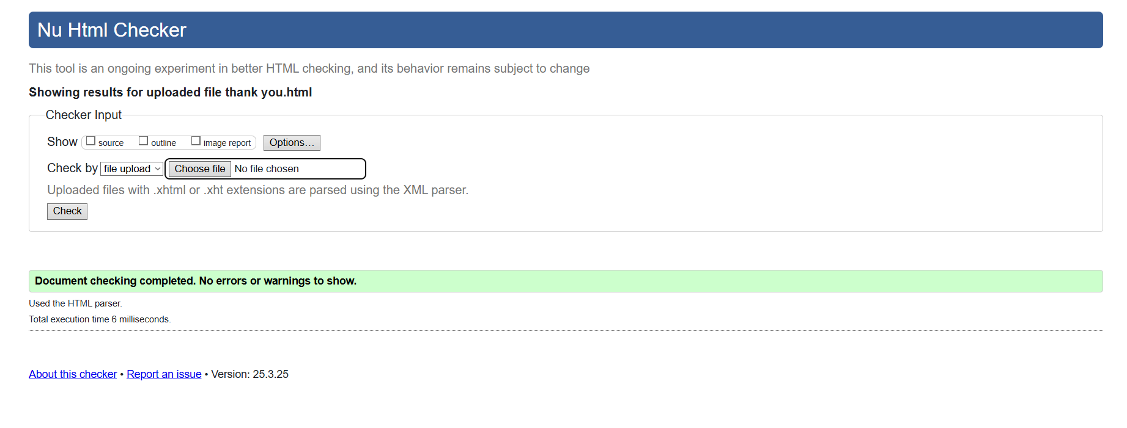

**Fig. Validation for thank you.html**

*6.3. CSS Validation*

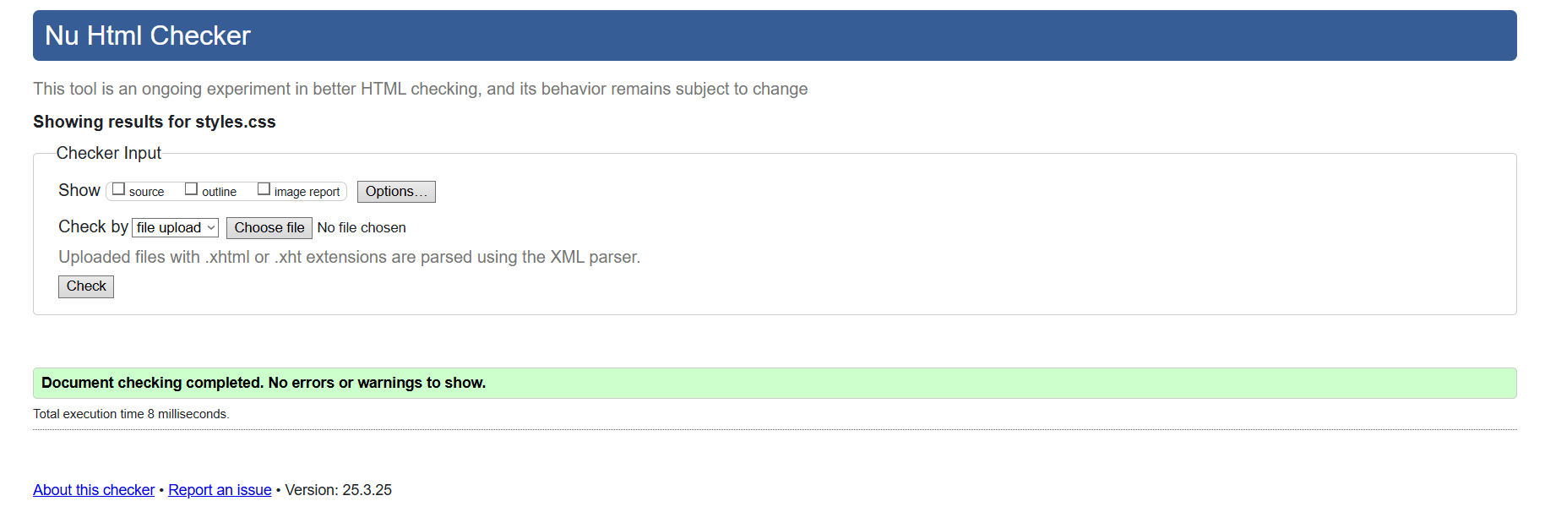

**Fig. Validation for styles.css**

**Section 7: Author Contributions**

The group members are: Anastasia Kajalic (M00982467), Basma Sameer (M01040352), Raghad Barmem (M01039213) and Shaavetha Mohankumar (M01039389).

The first days of completion of the coursework involved the team members formulating the storyboard and brand identity, researching extensively about the web development tools to be used. The main page of the website was built by Anastasia, focusing attention on implementing a consistent navigation bar, functioning links across the page, and providing compatible layout and content. Additional web pages such as the ‘Contact Us’ page (created by Shaavetha), ‘About Us’ (created by Anastasia), ‘Checkout’, ‘Login’ and ‘Payment’ (all three created by Raghad), were integrated to the website as well. Shaavetha was responsible for creating and implementing the sidebar navigation for the main page, Contact Us page, and the About Us page. Our goal was to ensure a consistent, user-friendly navigation experience across the website for pages that require a scroll

The external CSS file was built in collaboration by the team, which implemented necessary, non-redundant, global and specific styles, following the DRY principle (Don’t Repeat Yourself), which aided in formatting individual web pages each member was assigned to. This task was overseen by Raghad and Anastasia.

Shaavetha was responsible for creating and overlooking the XML file, DTD file, and the barebones for XSLT. The details for each album in the XML file, such as description, records, artist name, album title, and price, was curated in a structured way, allowing for seamless integration of data and providing integral support in creating the storefront page.

Basma was in charge of creating the storefront for the website to display the albums sold. It was sorted out by the genre, supported by Shaavetha’s data integration through XSLT and XML. The album cover, description, price, ‘add to cart’ and quantity button for each album was coded with focus on readability and presentation.

Towards the end, the compilation and verification for functionality of each element and web page, in addition to comments, rechecking, and optimisation of code was a collaborative effort.

**Section 8: Reflection**

* **Anastasia Kajalic (M00982467)**

This coursework curated my foundational understanding of HTML to a higher-level usage of it. It allowed me to explore the extents of HTML and CSS styling, as well as provide me the knowledge to rid of redundant code through validation. Moreover, I learned the basics of XSLT, XML, and DTD, as well as the implementation of it within code. Even though basic, it gave me a much deeper understanding of web designing, coding, and transformation of code.

I enjoyed working on the coursework with my teammates a lot and I had gained a lot of knowledge out of it. Even though there were areas of miscommunication and disagreements, they were overcome through determination to see completion of our task.

* **Basma Sameer (M01040352)**

Doing this coursework was beneficial in understanding the basics of web development using HTML and CSS. Implementing XML and XSLT to display the album details helped reduce redundant data that would have existed if the information was hard-corded into HTML. I thoroughly enjoyed the process of transforming the storyboard design into a website using the topics taught.

The team members were an essential part in the successful and satisfactory completion of the coursework. Everyone actively took part in their individual task and was driven to thoroughly understand each topic.

* **Raghad Barmem (M01039213)**

When it comes to making a website, basic understanding matters which is the key to making a successful website. With the help of this coursework I was able to understand how to structure the content using HTML and how to make it aesthetically pleasing by using CSS. This project made me realize how consistency can be very important when it comes to fonts,colors and the overall design.Overall this experience helped me build a strong base when it comes to web development.

I even got to experience XML and XSL even though it wasn't my main responsibility. Working with these helped me understand how data can be separated from design and how they can be connected to create dynamic, flexible web content. Overall the team members were the most crucial part in making this website a successful outcome, in which everyone had their own task to deal with and can be shared if anything goes wrong.

Overall, the team members were the most important factor in the success of this website; each person had a specific task to do and could discuss if something went wrong.

* **Shaavetha Mohankumar (M01039389)**

This coursework was a valuable experience that helped me improve my web development skills using HTML and CSS. I was able to learn about XML, DTD, and the basics of XSL to understand the importance of data structure, validation and redundancy. I was able to explore various methods of styling elements with HTML and CSS, while also learning the extent to which I can customize and create unique designs. My group members were essential to the success of meeting deadlines without compromising on the quality, despite being on a time crunch.

Overall, this has given me hands-on experience and strengthened my technical skills. I now feel more confident in working on future collaborative projects.

**Section 9: Takeaways & Conclusion**

Week 7 to 12 lectures provided foundational knowledge of HTML, CSS, XML, XSLT, and DTD. Building on these concepts, our team applied them to design and develop *Rustic Rhythms*, a simulated music store website. The main objective was for a visually appealing and interactive website that displayed well-formatted content, applied appropriate styling, implemented hyperlinks to buttons for functional navigation, and implemented animations to enhance interactivity and user experience.

We began with HTML to construct the foundation of our website, where CSS ensured styling and formatting for a cohesive design. The storefront page was developed with XML and XSLT, allowing us to display the albums dynamically organised by genre. DTD validated our XML file and ensured a structured approach to store and manage album details.

While the initial phase of the website was done with ease, topics of XML and XSLT presented few challenges. We encountered issues such as incorrect outputs and formatting inconsistencies. However, through individual and independent research, debugging, and guidance from our SLA and professor, we resolved these problems and furthered our progress.

Overall, this assignment was quintessential in laying out the groundwork for web development tools, particularly in understanding how to implement them concisely and correctly. It encouraged problem-solving through trial and error and strengthened our collaboration, giving us practical experience in building a multi-file, standards-compliant – through validation – website from scratch.

**Section 10: References**

*W3Schools.com*. (n.d.). <https://www.w3schools.com/html/>

*W3Schools.com*. (n.d.-b). <https://www.w3schools.com/css/>

*W3Schools.com*. (n.d.-c). <https://www.w3schools.com/xml/>

*W3Schools.com*. (n.d.-c). <https://www.w3schools.com/xml/xsl_intro.asp>

*W3Schools.com*. (n.d.-c). <https://www.w3schools.com/xml/xml_dtd_intro.asp>

*Wikipedia, the free encyclopedia*. (n.d.). <https://www.wikipedia.org/>

*W3Schools.com*. (n.d.-d). <https://www.w3schools.com/xml/ref_xsl_el_param.asp>

Web, X. F. T. M. (2024, November 18). How to use to perform a simple lookup in XSLT. *Medium*. [https://xsltforthemodernweb.medium.com/beginners-xslt-patterns-explained-simple-key-lookup-601925820f3](https://xsltforthemodernweb.medium.com/beginners-xslt-patterns-explained-simple-key-lookup-601925820f3a)

MDN contributors. (2020a, September 15). @keyframes. Retrieved April 8, 2025, from MDN Web Docs website: <https://developer.mozilla.org/en-US/docs/Web/CSS/@keyframes>

MDN contributors. (2020b, September 15). clamp() - CSS: Cascading Style Sheets | MDN. Retrieved April 8, 2025, from developer.mozilla.org website: <https://developer.mozilla.org/en-US/docs/Web/CSS/clamp>

MDN contributors. (2020c, September 15). easing-function - CSS: Cascading Style Sheets | MDN. Retrieved April 8, 2025, from developer.mozilla.org website: <https://developer.mozilla.org/en-US/docs/Web/CSS/easing-function>

MDN contributors. (2022, January 27). animation-timeline. Retrieved April 8, 2025, from developer.mozilla.org website: <https://developer.mozilla.org/en-US/docs/Web/CSS/animation-timeline>

MDN contributors. (2023, June 26). animation-range - CSS: Cascading Style Sheets | MDN. Retrieved April 8, 2025, from MDN Web Docs website: <https://developer.mozilla.org/en-US/docs/Web/CSS/animation-range>

Meyer, E. A. (2019). CSS Tools: Reset CSS. Retrieved April 8, 2025, from Meyerweb.com website: <https://meyerweb.com/eric/tools/css/reset/>

W3Schools. (2019a). CSS Flexbox (Flexible Box). Retrieved April 8, 2025, from W3schools.com website: <https://www.w3schools.com/css/css3_flexbox.asp>

W3Schools. (2019b). CSS Grid Layout. Retrieved April 8, 2025, from W3schools.com website: <https://www.w3schools.com/css/css_grid.asp>

W3Schools. (2024a). HTML Tutorial. Retrieved April 8, 2025, from W3schools.com website: <https://www.w3schools.com/html/>

W3Schools. (n.d.). HTML blockquote tag. Retrieved April 11, 2025, from W3schools.com website: <https://www.w3schools.com/TAGS/tag_blockquote.asp>

W3Schools. (2024b). W3Schools.com. Retrieved April 8, 2025, from W3schools.com website: <https://www.w3schools.com/cssref/atrule_keyframes.php>